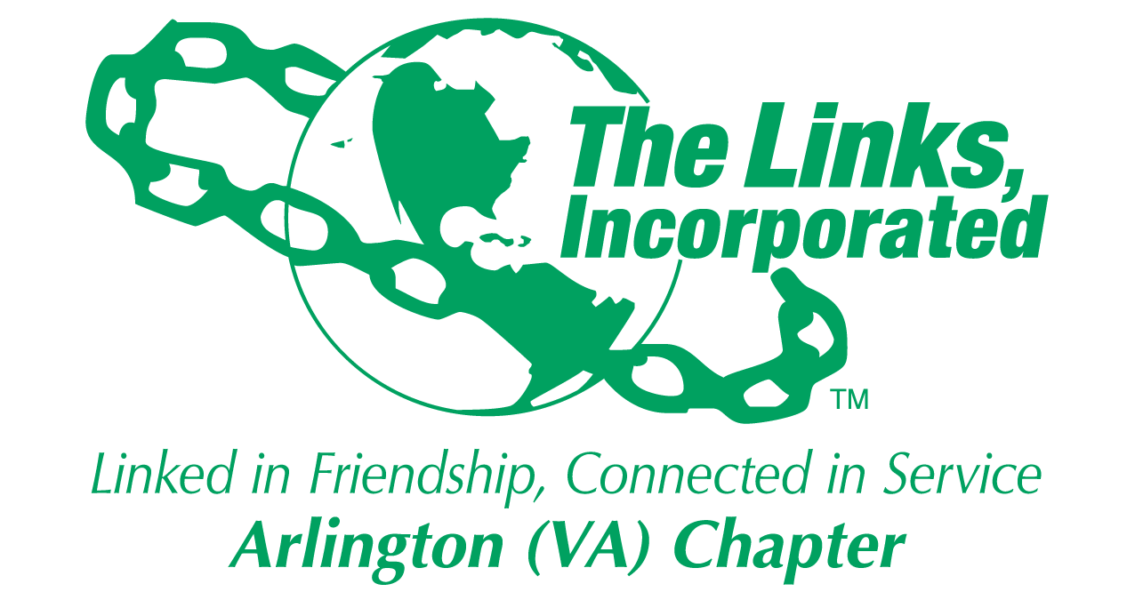

Arlington (VA) Chapter
The Links, Incorporated
Chapter Meeting
Saturday, April 12, 2025

Minutes

Call to Order: The Arlington (VA) Chapter meeting was called to order at 11:03 a.m. on April 12, 2025, and placed on recess until 12:30 p.m. Link Suzanne Walker, Chapter President, presided and Link Yvette Darnaby, captured the meeting minutes.

Quorum: At 12:30 p.m. Link Yvette informed Link Suzanne there were 39 members in attendance. Link Suzanne affirmed the quorum and called the meeting to order at 12:30 p.m.

Links Pledge: The Chapter attendees recited the Pledge.

The National Song: The Chapter attendees sang The National Song.

Welcome: Link Suzanne welcomed everyone to the April Chapter meeting.

Guest: Link Suzanne recognized and welcomed Link Sonali B. Wilson, alumni member visiting from the Cleveland Chapter.

Birthday Acknowledgement: Link Suzanne extended a Happy Birthday greeting to everyone celebrating a birthday in the month of April. Members born in the month of April were asked to stand and the Chapter sang the Happy Birthday song.

Approval of the Agenda: Due to the delayed start time, Link Suzanne recommended that the Chapter conduct the election of Chapter Officers followed by the Monte Carlo Report. By consensus, the meeting agenda was approved with the noted adjustments.

Election of Chapter Officers
- Link Suzanne presented the slate of candidates:
  - President: Link Tameka Tunsil
  - Vice President: Link Theresa Peterson
  - Recording Secretary: Link Yvette Darnaby

- Link Suzanne called for nominations from the floor three times for the following positions:
  - President
  - Vice President
  - Recording Secretary

- There were no nominations made from the floor for the position of President, Vice President nor Recording Secretary.

- In accordance with Robert’s Rules of Order, Link Tameka Tunsil, Link Theresa Peterson, and Link Yvette Darnaby, were electied via acclimation without objection.

- Link Suzanne called for nominations from the floor for the position of Treasurer.
  - Link Caroline Lang nominated Link Francine Lane and Link Francine accepted the nomination.
  - Link Suzanne called for nominations from the floor two more times for the position of Treasurer. No other nominations were made.
  - In accordance with Robert’s Rules of Order, Link Francine Lane was elected via acclimation without objection.

- Link Arkena Dailey and Link Janice Welburn requested that their names be removed from the Nominating Committee candidate pool.

- Link Suzanne called for nominations from the floor three times for the Nominating Committee.
  - The Chapter voted via ballot and the following candidates were elected:
    - Elaine Bush (Chairman)
    - Nastasha Rountree
    - Avril Ussery Sisk
    - Cheryl Coleman Hall
    - Yolanda Holmes

Officer Reports

President’s Report – Link Suzanne Walker
- Link Suzanne will upload a report to the Chapter’s website.

Vice President’s Report – Link Tameka Tunsil
- There are no changes to the Chapter profile for the month of April.
- Congratulations to Platinum Member, Link Emily Bryant.
- Kudos to the Alumna and Platinum Virtual Tea committee for hosting the virtual tea.
- Book Reading: Parable of the Talents see Link Cheryl Coleman Hall for details.
- Membership Acknowledgement Plan (MAP) was submitted ahead of the submission date.
- The Chapter Retreat will be held on Saturday, June 14, 2025.

Core Value: Integrity

Current Membership: 80
Active: 76 | Leave of Absence: 3
Platinum: 3 | Pending Transfers: Out: 0
PNP: 1 | Recent Transfer In: 0
Dual Members (P): 1 | LOA Requests: 2
Dual Members (S): 2 | DOLs: 23

Financial Secretary’s Report – Theresa Peterson: A report was provided.
- All members have paid their dues.
Treasurer’s Report – Link Rose Boyd: A report was presented.

Monte Carlo: Link Tycely Williams
- Link Rose Boyd read the revenue, expenses and net profit for Monte Carlo 2025.
- Link Tycely Williams presented the Budget to Actual Report.
- The committee will bring a motion to the Chapter to speak to items purchased for Monte Carlo that were not included in the budget.

- Motion:
  - Link Tycely made a motion to approve an outstanding debt for floor decals for a sponsor benefit paid by Link Lavern Chatman totaling $1145.36.
  - The Chapter voted by voice to approve the payment without objection.

- Link Tycely informed the Chapter that the budget was exceeded in the areas of gaming, hotel AV/technology, and entertainment.

- The committee received only 27 responses to the Monte Carlo survey. To gather additional input the Committee will resend the survey, extending the response deadline to Friday, April 18, 2025.

- The Committee requests an accounting of all in-kind expenditures to include, dresses, food, transportation and makeup for the Young Professional volunteers.

- The Committee is working to upload photographs taken at Monte Carlo to the Chapters website. There is no charge to the Chapter for photographs taken at the event.

- Link Tycely is working with Link Rose to prepare a final financial report.

Eastern Area Election

- Motions
  - Link Yvette Darnaby moved that Chapter members present at the Eastern Area Conference caucus to make a recommendation on who to vote for the position of Recording Secretary.
    - The Chapter voted by voice to Caucus at the conference to make a recommendation on who to vote for the position of Recording Secretary.
    - Without objection the motion was approved.

  - Link Evelyn Gee moved that the Chapter vote for Blanche Jackson for the position of Eastern Area Treasurer.
    - The Chapter voted by voice to support Link Blanche Jackson for the position of Eastern Area Treasurer.
    - Without objection the motion approved.

Announcements
- Link Janice Welburn was re-elected to the American Library Association Council to serve the 2025-2028 term. She had the second highest number of votes.
- Link Michelle Jones won second place for her poster presentation for research.

The meeting adjourned at 2:01 p.m.

Link Yvette Darnaby
Recording Secretary
Date Approved: TBD

