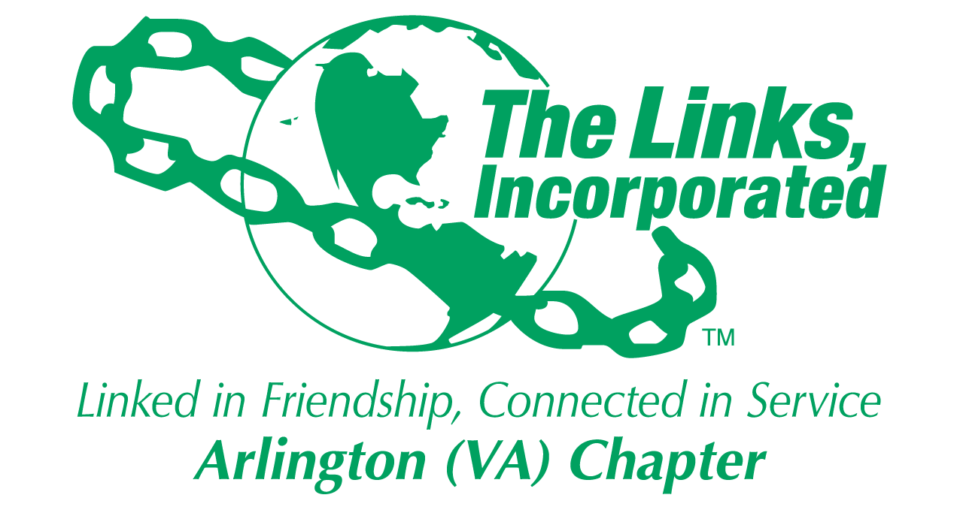

Arlington (VA) Chapter
The Links, Incorporated
Chapter Meeting
Saturday, May 10, 2025

Minutes

Call to Order: The Arlington (VA) Chapter Meeting was called to order at 11:33 a.m. on May 10, 2025. Link Suzanne Walker, Chapter President, presided and Link Francine Lane, captured the meeting minutes.

Quorum: At 11:33 a.m. Link Francine informed Link Suzanne there were 39 members in attendance. Link Suzanne affirmed the quorum and called the meeting to order at 11:33 a.m.

Links Pledge: The Chapter attendees recited the Pledge.

The National Song: The Chapter attendees sang The National Song.

Welcome: Link Suzanne welcomed everyone to the May Chapter meeting.

Linkspiration: Link Suzanne thanked Link Cheryl Coleman Hall for serving as Chaplain during her term as Chapter President. Link Cheryl asked each chapter member to say one word describing their feeling today. She then described the Importance of using the value of the differences in our collective participation. Wished all a Happy Mother’s Day.

Birthday Acknowledgement: Link Suzanne extended a Happy Birthday greeting to everyone celebrating a birthday in the month of May. Members born in the month of May were asked to stand and the Chapter sang the Happy Birthday song.

Approval of the Agenda: Agenda was presented and accepted as presented.

Officer Reports

Link Suzanne asked chapter member if they would approve Link Francine as Recording Secretary pro tem for this meeting and all approved.

President’s Report – Link Suzanne Walker
Link Suzanne presented highlights of her term as chapter president – People, Programming, Process
- People – friendship and service bonded well; national leadership cohorts; achieved quorum for chapter meetings; successful Monte Carlo event; filled elected positions, participated in events at all levels (local, regional and national), rallied around sisters in times of need.
- Programming - 4th place National Award, Eastern Area Transformational Programing Award and Eastern Area 1st place Oral History Project - award winning chapter; successful Madame Ambassador Program, successful Connecting Links Golf Tournament for scholarship fund, 4 scholarship recipients.
- Process – most difficult; Link Michelle Bailey tried to get the processes on track. Established many avenues for information sharing. It is up to members to read the documents.

National Updates – Review emails regarding webinar offerings.

Eastern Area Report will come in June.
After action Monte Carlo meeting on Zoom May 12th at 7:00 pm.
Preparing for internal and external audit.
June 14th Chapter Retreat
June 17th Golf Tournament
May 27th at 6pm and May 31st at 3 pm – Golf lessons at VA Golf Center – Contact Link Suzanne - do not need clubs, may rent clubs or borrow from Link Suzanne

Thanked chapter members for support during her tenure as chapter president

Vice President’s Report – Link Tameka Tunsil
Link Tameka - presented Link Suzanne with a gift of appreciation from the chapter for her service as Chapter President.

Current Membership: 80
Active: 76 | Leave of Absence: 4
Platinum: 4 | Pending Transfers: Out: 0
PNP: 1 | Recent Transfer In: 0
Dual Members (P): 2 | LOA Requests: 2
Dual Members (S): 2 | DOLs: 23

Reminders:
- Keep track of meeting attendance for the year
- Track service hours in Track it Forward
- Hosting cycle will start for upcoming year
- Chapter meeting and Retreat June 14th

Celebrating graduates and Mother’s Day
Acknowledged Link Devera Redmond for 25 years as a member of The Links, Incorporated
Thanked chapter member for support during her tenure as Chapter Vice President.

Core Value: Legacy

Financial Secretary’s Report – Theresa Peterson: A report was provided.
- Thanked Link Evelyn Gee, Link Lynn LaValle, and Link Rose Boyd for support as she served as Financial Secretary.

Treasurer’s Report – Link Rose Boyd: A report was presented.
- Thanked Link Lynn LaValle and Link Evelyn Gee for their support.

Corresponding Secretary – Link Michelle Bailey:
- Congratulation to Link Michelle Jones on PhD graduation – showed picture from graduation
- Thanked those who updated their contact information
  - shout out to Link Sandra Clark for reaching out to alumna members to update contact information
- Please update committee or facet involvement (check handbook for requirement)
- Have pictures for everyone to update the directory
- Read correspondence from Link Therea Peterson thanking chapter for support during time of need

Chapter Minutes
April Chapter minutes were accepted as submitted.
- Chapter minutes are posted on the website
- Historical minutes will need to be stored in perpetuity. Need to determine the best way to store the minutes.

Recording Secretary – Link Francine Lane (pro tem): no report

Programing – Link Hope Goins
- Received certificate for Transformational Programing at Eastern Area Conference
- NTS - No report
- STY - No report
  - NSBE JR. Link Marietta Palmer on behalf of Link Rachel English –
      - Final meeting for Drew Elementary; 30 certificates of completion delivered
      - Thanked Link Erni, Link Janice, Link Suzanne and Link Denise for their support
      - Read the speech from the NSBE Jr President at Drew Elementary
      - Plan to attend June 8th chartering ceremony for the Mt Zion NSBE chapter
- ITS will present at June meeting

Ethics – Link Hope Goins: Received allegation of misconduct and the committee has been meeting

Strategic planning – Link Evie Brown: Starting new 5-year cycle; will address 6th priority - leadership and development; will address amplified goals at the retreat.

Scholarship – Link Erni Bridges: 2 graduating scholarship recipients (4 total scholars); asked to feature scholars in the golf tournament program

Technology – Link Krysta Jones: No report

Special Reports

Monte Carlo –
After action debrief will be held on Monday May 12th
40 link sisters participated in the survey – showed summary of survey results

Golf Committee – Link Evelyn Gee and Link Evie Brown: Link Evie explained the history of golf tournament with purpose to raise money to support scholarship.
There is a web tool for the Golf Tournament that will allow funds to be paid directly to the foundation. Reviewed the sponsorship levels and thanked members for their contributions.
Tournament committee meeting on Wednesday nights
Played Golf Trivia game and prizes awarded. Trivia questions created by Link Faith Blackburn

Installation of Officers conducted by Link Suzanne Walker
Installed officers included:
President - Link Tameka Tunsil
Vice President - Link Theresa Peterson
Treasurer - Link Francine Lane
Recording Secretary - Link Yvette Darnaby (stand-in)
Nominating Committee:
    - Elaine Bush Chairman (stand-in)
    - Nastasha Rountree (stand-in)
    - Avril Ussery Sisk
    - Cheryl Coleman Hall
    - Yolanda Holmes (stand-in)

New Chapter President Link Tameka Tunsil commenced the meeting and asked for assistance from the chapter members to take on roles when asked to lead committees and facets.

Announcements
Raffle of prizes at end of meeting
Link Evie Brown’s granddaughter was accepted to the UC Berkley Pre-engineering program
Link Hope accepted as EA Program Resource Liaison

The meeting adjourned at 1:07 p.m.

Link Francine Lane
Recording Secretary, Pro Tem
Date Approved: TBD

Attendance

Francine Lane
Tameka Tunsil
Theresa Peterson
Tammie Smiley
Cheryl Coleman Hall
Devera Redmond
Marietta Palmer
Angell Jacobs
Nickie Martin
Michelle Bailey
Kim Campbell Young
Evie Brown
Emily Bryant
Lisa Lee Packer
Karen Wright
Brenda Martin
Krysta Jones
Suzanne Walker
Julia Pollard
Avril Ussery Sisk
Sandra Clark
Bridget Bailey Lipscomb
Heather Hill
Tamara Null
Lynn LaValle
Rose Boyd
Arkena Dailey
Janice Welburn
Hope Goins
Denise Bruner
Michelle Mason
Candice Tobin
Evelyn Gee
Telesa Via
Ernestine Bridges
Karyn Temple
P Michele Ellison
Faith Blackburn Proctor
Felecia Phillips-Welch
Aleta Johnson
Shanna Travis
Diane Butts
Karen Hughes

