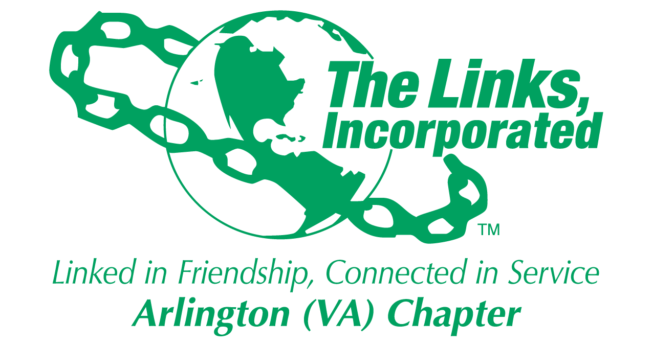

Arlington (VA) Chapter
The Links, Incorporated

Special Meeting: Monte Carlo Post Event Debrief – Monday, May 12, 2025
Minutes

Called to Order: The Monte Carlo Post Event Debrief of the Arlington (VA) Chapter was held via Zoom on Monday, May 12, 2025. The meeting convened at 7:03 p.m. Link Tameka Tunsil, Chapter President, presided and Link Yvette Darnaby, captured the meeting minutes.

Attendees:
Link Suzanne Walker | Link Julia Pollard | Link Ashley Flakes | Link DeVera Redmond
Link Tameka Tunsil | Link Melendee Canady | Link Francine Lane | Link Wendy Bostic
Link Rose Boyd | Link Erni Bridges | Link Hope Goins | Link Lavern Chatman
Link Yvette Darnaby | Link Michelle Jones | Link Tycely Williams | Link Lisa Lee-Packer
Link Janice Welburn | Link Karen Wright | Link Marietta Palmer | Link Diane Smith
Link Michelle Bailey | Link Shanna Travis | Link Aleta Johnson | Link Avril Sisk
Link Nona Eath | Link Rachel English | Link Anita Walker | Link Nicki Martin
Link Diane Harley | Link Tammie Smiley | Link Cheryl Coleman Hall | Link Yolanda Holmes
Link Faith Blackbune | Link Lori Stith | Link Arkena Dailey | Link Elaine Bush
Link Kimberly Parker | Link Natasha Rountree | Link Karen Hughes | Link Emily Bryant
Link Angell Jacobs

Topic: Monte Carlo Post Debrief

Link Tycely Williams and Link Shanna Travis, Monte Carlo Co-Chairs provided a high-level overview of the Monte Carlo survey results:
- Forty Chapter members completed the survey.
- The areas that received the highest satisfaction ranking were:
  - DJ
  - Theme
  - Entertainment

- Other survey feedback:
  - Money was left “on the table”
  - No HBCU spotlight
  - Text to Give was inoperable
  - Hotel parking was a pain point
  - Awkward dance floor placement

- Recommendations from the Co-Chairs:
  - Need stronger checks and balances when using the OneCause software.
  - Clearly defined Chairman/Co-chairman and committee member roles and responsibilities.
  - Need more Chapter members to assume leadership roles.

- Observations/Comments from the Co-Chairs:
  - There was a Monte Carlo website set up however, the Co-Chairs did not have access to the site.
  - The One-Cause software was deactivated during the event which caused confusion and an inability to donate during the event.
  - The Chapter missed deadlines and did not always adhere to written guidelines.
  - At midnight the hotel charged for another day of parking.
  - The use of Eventbrite closed on February 28, 2025.
  - The hotel worked closely with the Co-Chairs to meet program needs.
  - The goal was to pay all bills by March 9, 2025. To meet the goal the Link Shanna paid bills out of pocket which resulted in large reimbursement entries.
  - The event did not exceed the overall approved budget.

Recommendations and Comments from the Chapter
- Invest in a survey license.
- Look at larger venues outside of the Arlington area for future events.
- Pair up future Chairs/Co-Chairs with a seasoned Chapter member to provide historical education/guidance.
- The Chapter did not adjust the budget/expenses with the budget/revenue, funding absorptions and in-kind donations must be reflected within the budget.
- Give concerted consideration as to how we use the Chapter assessment i.e.., host a big party or programming needs.

Closing:
- Link Shanna and Link Tycely extended thanks, appreciation and gratitude to Link Evelyn Gee, Link Lynn Lavalle and Link Rose Boyd for their support and guidance. They also thanked Link Suzanne Walker for supporting them throughout the process.

Meeting adjourned at 8:10 p.m.

Link Yvette Darnaby
Recording Secretary
Date Approved: TBD

