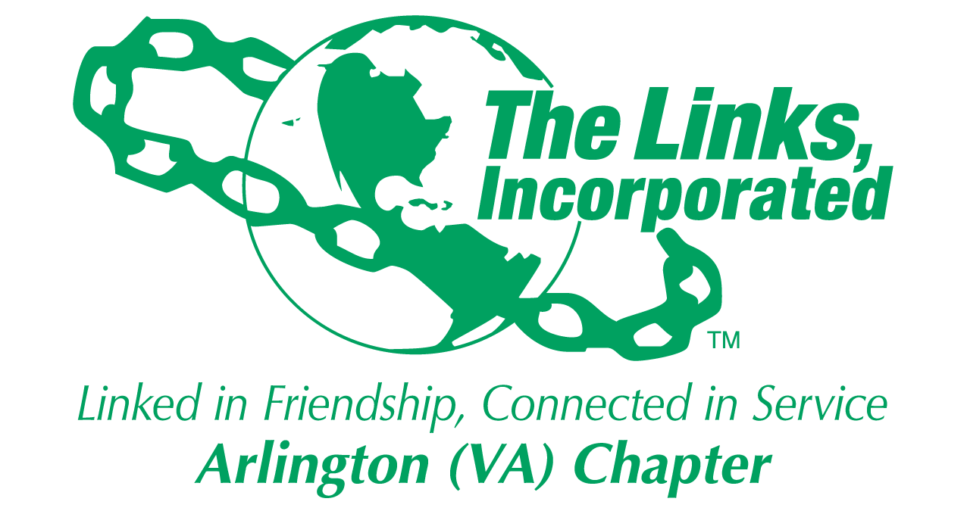

Arlington (VA) Chapter
The Links, Incorporated
Chapter Meeting
Saturday, June 14, 2025

Minutes

Call to Order: The Arlington (VA) Chapter Meeting was called to order at 11:15 a.m. on June 14, 2025. Link Tameka Tunsil, Chapter President, presided and Link Yvette Darnaby, captured the meeting minutes.

Quorum: At 11:15 a.m. Link Yvette informed Link Tameka there were 41 members in attendance. Link Tameka affirmed the quorum and called the meeting to order at 11:15 a.m.

Links Pledge: The Chapter attendees recited the Pledge.

The National Song: The Chapter attendees sang The National Song.

Welcome: Link Tameka welcomed everyone to the June Chapter meeting.

Linkspiration - Link Cheryl Coleman Hall
- Living a life focused on harmony portrays the importance of humility, kindness, and compassion in building strong relationships and promoting a sense of belonging.

Birthday Acknowledgement: Link Tameka extended a Happy Birthday greeting to everyone celebrating a birthday in the months of June and July. Members born in the months of June and July were asked to stand and the Chapter sang the Happy Birthday song.

Approval of the Agenda: Link Tameka called for changes to the agenda.
- Link Michelle Jones will serve as the Parliamentarian Pro-tem in Link Angela Foster’s absence.
- Change the date of the Golf Classic to read June 16th

Approval of the Minutes
- The minutes for the May 10, 2025, Chapter Meeting were approved by voice vote without objection.
- The minutes for the May 12, 2025, Post Monte Carlo Debrief meeting were approved by voice vote without objection.

Officer Reports

President’s Report – Link Tameka Tunsil
- The Chapter officer’s profile has been updated in MMS to reflect the names of all elected officers.
- Annual Meeting of The Links Foundation, Incorporated will be held on Wednesday, August 6, 2025, at 8:00 p.m.
- The Eastern Area officer training will commence in August.
- Elevating Chronicles submission deadline is September 15, 2025.
- Appointed Chapter Officers:
  - Financial Secretary – Link Caroline Lang
  - Corresponding Secretary – Link Michelle Bailey
  - Parliamentarian – Link Angela Foster
  - Assistant Treasurer - Link Rose Boyd
- The Chapter Retreat will be held August 2, 2025.
- An emergency request seeking financial assistance was received from a parent to pay an outstanding balance for her daughter to return to Howard University. The Chapter successfully coordinated with the Thurgood Marshall Scholarship Fund to provide emergency financial assistance.

Vice President’s Report – Link Theresa Peterson
- The Chapter Retreat will be held on Saturday, August 2nd at Link Francine’s home.
- Track it Forward “Road to 48”, enter all service and meeting hours early.
- The following members were recognized for their timely Track it Forward entries:
  - Link Lisa Lee Packer
  - Link Denise Bruner
  - Link Evelyn Gee
  - Link Suzanne walker
- Link Nona Eath and Link Shanna Travis request to transfer out was approved.

Core Value: Family Relationships

Current Membership: 79
Active: 74 | Leave of Absence: 4
Platinum: 4 | Pending Transfers: Out: 1
PNP: 1 | Recent Transfer In: 0
Dual Members (P): 2 | LOA Requests: 0
Dual Members (S): 2 | DOLs: 21

Financial Secretary’s Report – Link Caroline Lang: Link Theresa Peterson provided the written report.

Treasurer’s Report – Link Francine Lane: Link Rose Boyd provided the written report.

Recording Secretary’s Report – Link Yvette Darnaby: No Report

Corresponding Secretary’s– Link Michelle Bailey
- The Chapter pictorial directory will be issued this month. All photos have been received.

Monte Carlo – Link Rose Boyd
- A financial report was presented.
- Following extensive discussion and Q&A’s, Link Tameka asked the Committee to update the report categorizing line items for ease of reference for the auditor and the Chapter to track and follow all entries.
- Link Tycely Williams will ensure that the link to the photos taken by the photographer will be reposted in the upcoming Weekly Correspondence.
- The Committee made several recommendations to include a requirement that the Finance Team and someone with a legal background review all contracts before they are executed.

NTS – Link Cheryl Coleman Hall, Link Krysta Jones, and Link Tamara Nall
- Early voting in Virginia ends on June 17th.
- All Chapter members are encouraged to familiarize themselves with the POTUS “Big Ugly Bill”
- Support black owned businesses during the month of June.
- While serving as the lead Chapter, NTS endeavors to expand its current podcast to engage area DMV Link Chapters:
  - At least 12 episodes per year.
  - At least 2 chapters to collaborate on each podcast covering topics related to the five facets per year.
  - Contributing chapters to donate $100 per year for editing and promotions.
- Link Krysta Jones made the following motion on behalf of the Committee:

Motion: I move that the Chapter expand our podcast to be a collaborative program in conjunction with interested DMV Link Chapters that provides community education on key programs and community issues aligned with Links programs and priorities.

The motion was approved by voice vote without objection.

- Link Krysta Jones made the following motion on behalf of the Committee:

Motion: I move that we collaborate with other Virginia Link Chapter on a virtual statewide candidates’ forum in September or October 2025 for a cost of $100 from the Chapter.

- Following extensive discussion on how the Chapter will maintain a bipartisanship posture within the community, Link Rose Boyd made the following motion:

Motion: I move that we lay the previous motion on the table until September.

The motion received a second and was approved by voice vote with one objection.

History Committee – Link Rachel English
- The Chapter won the first-place award of $1000 from the Eastern Area for our Oral History Video Project submission.
  - The award-winning ten-minute video was played.
- The Chapter's written narrative for The Links, Incorporated National History Book is due June 30, 2025.

Golf Classic – Link Suzanne Walker
- The event will be held on June 16th; the committee is working with the venue to determine protocol if it rains.
- Volunteers are needed the day of the event from 7 a.m. to 1 p.m.
- All volunteers must pay the $25 lunch assessment today.
- The Committee needs all names of golfers and volunteers by 5 p.m. today.

Red Dress – Link Michelle Bailey
- The Committee is preparing for Red Dress 2026.

Standing Committee Reports:

Programs –Link Hope Goins:
- The Eastern Area released the Program Guide - Elevating Chronicles. Chapter members are encouraged to review the new guide and take photos in front of historical black sites.

STY - Link Chevette Mooney: No Report

ITS – Link Sharon Jackson Wilder and Link Tammie Smiley: No Report

The Arts – Link Aleta Johnson and Link Brenda Martin: No Report.

HHS - Link Shanna Travis and Link Angel Jacobs: No report

Ethics – Link Melandee Canady
- Link Hope Goins announced that she was stepping down after serving six years as the Chair of this committee.
- The Committee met throughout May to address an ethical misconduct allegation. The investigation concluded and there will be no further action on this matter.

Announcements
- The date of the Golf Classic is June 16, 2025.
- The Chapter Retreat will be held on August 2, 2025.
- The National Assembly will be held in Detroit, June 24 to 28, 2026.

The meeting adjourned at 1:21p.m.

Link Yvette Darnaby
Recording Secretary
Date Approved: TBD

First | Last | Status
A. Elaine | Bush | 1
Aleta | Johnson
Alma Cobb | Hobbs
Alyce Femister | Gaither
Angela | Foster, Esq.
Angell | Jacobs | 1
Anita | Walker | 1
Anne S. Pruitt | Logan
Arkena | Dailey | 1
Ashley | Flakes | 1
Avril Ussery | Sisk | 1
Barbara B. | Evans+
Belinda W. | LaValle | 1
Brenda | Martin, PhD
Bridget Bailey | Lipscomb, Esq. | 1
Candice | Tobin
Carla D. | Johnson
Caroline | Lang, PhD | 1
Cheran Cordell | Ivery
Cheryl Coleman | Hall | 1
Cheryl Lynn Jackson | Lewis
Chevette | Mooney | 1
Dawn | Johnson | 1
Denise E. | Bruner, MD | 1
Denise Gibson | Bailey | 1
DeVera Y. | Redmond | 1
Diane | Butts | 1
Diane M. | Harley | 1
Drue Shropshire | Guy
Earnestine "Erni" | Bridges Borden | 1
Elizabeth Jackson | Hodges
Emily | Bryant
Evelyn "Evie" | Brown | 1
Evelyn E. | Gee | 1
Faith | Blackburne-Proctor | 1
Felecia Y. | Phillips-Welch | 1
Francine | Lane | 1
Gwendolyn Hubbard | Lewis
Heather | Hill
Hope | Goins | 1
Isabelle F. | Fant+
Janice | Welburn | 1
Juanita Wallace | Jackson
Julia A. | Pollard
Karen | Johnson, Esq.
Karen Jordan | Wright | 1
Karen Peters | Hughes
Karla | Ellison-Hoffman
Karyn | Temple
Kedren | Dillard | 1
Keisha Boggan | Campbell | 1
Kelly | Bolden, MD
Kim Campbell | Young | 1
Kimberly Jeffries | Leonard, PhD
Kimberly N. Parker | Pinder | 1
Krysta | Jones | 1
LaJuanna | Russell | 1
Lavern J. | Chatman | 1
Lillie Easley | Parker
Linda Jacobs | Washington
Lisa | Gregory, Esq.
Lisa | Lee-Packer | 1
Lori | Stith | 1
Maia | McCuiston, MD
Marietta S. | Palmer, EdD
Marion D. | Spraggins
Martha | Jones
Martine | Wilson | 1
Melandee | Jones | 1
Michelle | Mason | 1
Michelle M. | Bailey* | 1
Michelle Marie | Jones | 1
Natasha | Rountree | 1
Nicholette M. | Martin, MD
Nona | Eath
P. Michele | Ellison
Rachel | English | 1
Rose Williams | Boyd | 1
Sandra Jenkins | Clark
Shanna | Travis
Sharon Jackson | Wilder
Stephanie McManus | Collins
Sudonna | Moss Stevens, Ed.D.
Suzanne | Walker* | 1
Tamara | Nall
Tameka | Tunsil* | 1
Tammie | Smiley | 1
Telesa | Via | 1
Theresa | Peterson* | 1
Tycely | Williams | 1
Wendy | Bostic
Yolanda C. | Holmes, MD | 1
Yvette | Darnaby* | 1
 | Total: | 51
 | Present: 1
 | Excused: 2
 | Quorum: 37

