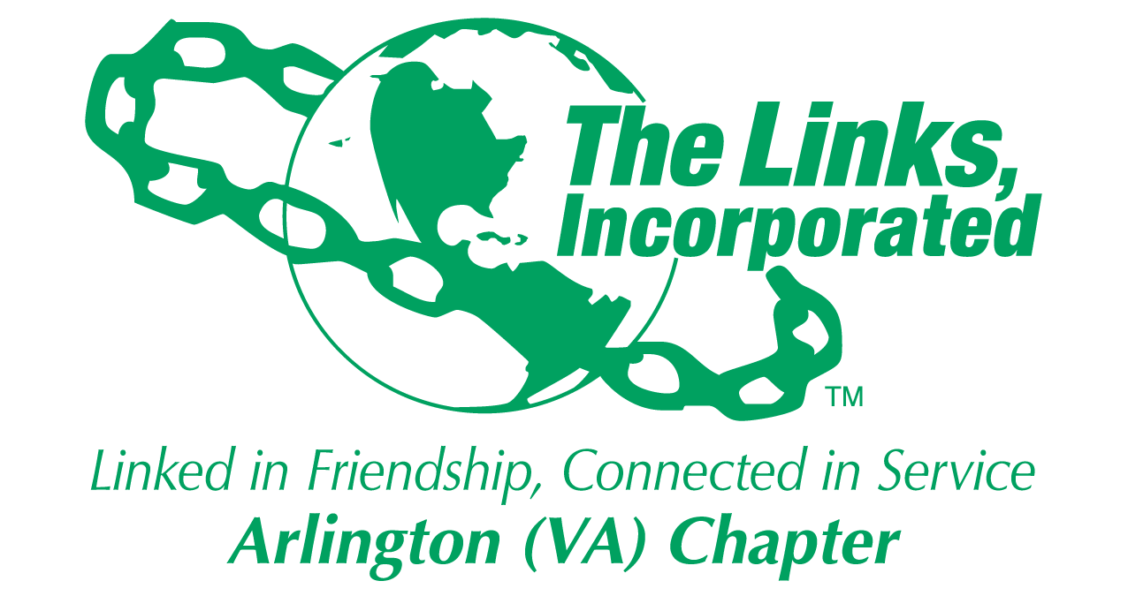

Arlington (VA) Chapter
The Links, Incorporated
Chapter Meeting
Saturday, September 13, 2025

Minutes

Call to Order: The Arlington (VA) Chapter Meeting was called to order at 11:19 a.m. on September 13, 2025. Link Tameka Tunsil, Chapter President, presided and Link Yvette Darnaby, captured the meeting minutes.

Quorum: At 11:19 a.m. Link Yvette informed Link Tameka there were 37 members in attendance. Link Tameka affirmed the quorum and called the meeting to order at 11:19 a.m.

Links Pledge: The Chapter attendees recited the Pledge.

The National Song: The Chapter attendees sang The National Song.

Welcome: Link Tameka welcomed everyone to the September Chapter meeting and asked for prayers for Link Cheryl Coleman Hall who was absent due to the illness of her husband.

Birthday Acknowledgement: Link Tameka extended a Happy Birthday greeting to everyone celebrating a birthday in the months of July, August, and September. Members born in these months were asked to stand, and the Chapter sang the Happy Birthday song.

Adoption of the Agenda: Without objection, the agenda was adopted as presented.

Approval of the Minutes: Without objection, the Chapter meeting minutes for the June 14, 2025, meeting were adopted as presented.

Officer Reports

President’s Report – Link Tameka Tunsil
- Legislative Luncheon, September 24, 2025, Washington, DC
- National Assembly, June 24 to Jun 27, 2026, Detroit, Michigan
- Scott Hawkins Leadership Institute, Cohort XIII applications due by October 2nd
- Ethics Training, October 30th and November 20th
- EA Conference 2027, March 31 – April 4, 2027, Buffalo, NY
- Black Family Wellness, March 21st
- Leadership Summit, October 3 - 5, 2025, Gaylord National Harbor
- DMV 30th Anniversary Walkathon, September 27, 2025 ($600 seed required).

Motion
- The Executive Committee moved that the Chapter approve $600 to serve as seed money in support of the DMV Walkathon which will be held on September 27, 2025.
- The motion did not require a second.
- Without objection the motion was adopted.

- The Nannie Lee Center will be the meeting location from September 2025 to June 2026.
- A new Chapter photo will be taken during the November 2025 Chapter meeting.
- Vacancies: HHS, Technology/ Communications, and Monte Carlo need support and volunteers.

Vice President’s Report – Link Theresa Peterson
- The glitch to fix Facet and Committee sign-ups using Sign-Up Genuis should be repaired this week.
- September Friendship Month Activity
  - Sign-up to see the play, Play On! at that Signature Theater, Arlington. See a member of the Membership Committee for sign-up information details.
- Friendship Activity - Link Michelle Jones distributed and lead an HBCU Crossword. Prizes were awarded.

Core Value: Honesty and Integrity

Current Membership: 78
Active: 74 | Leave of Absence: 4
Platinum: 4 | Pending Transfers: Out: 0
PNP: 1 | Recent Transfer In: 0
Dual Members (P): 2 | LOA Requests: 0
Dual Members (S): 2 | DOLs: 21

Financial Secretary’s Report – Link Caroline Lang: A report was provided.

Treasurer’s Report – Link Francine Lane: A report was provided. The Monte Carlo final report was presented. Both reports are available via the member’s only portal.

Recording Secretary’s Report – Link Yvette Darnaby
- Check in with the Recording Secretary for all Chapter meetings to receive attendance credit.
- Chapter Meeting Minutes are posted behind the members only portal under Monthly Membership Documents.

Corresponding Secretary’s– Link Michelle Bailey
- The Chapter pictorial directory will be issued this month.
- Members are asked to join 2 Facets and 1 Committee/Special Committee.

Parliamentary Patios – Link Angela Foster
- When you want to control how long a matter can be discussed you should make a motion to limit or extend debate.
- The motion requires a second.
- According to Robert’s Rules of Order, ten minutes is the designated time to speak on a topic per person.

Standing Committee Reports:

Programs –Link Hope Goins: Meetings with facet chairs are underway to ensure alignment with the Chapters Strategic Plan.

STY - Link Chevette Mooney: STEAM Plus program dates:
- November 22, 2025, and January 24,2026.

NSBE Jr. – Link Rachel English:
- The Chartering Ceremony for the Community Partnership Program of the Mount Zion Baptist Church, Future Engineers, NSBE Jr. Chapter will be held on Sunday, September 28th at 12pm. Address: 3500 19th St. S. Arlington, VA 22206. Contact Link Rachel for more information.
- If you plan to attend the chartering ceremony, please contact Link Rachel.

NTS – Link Cheryl Coleman Hall, Link Krysta Jones, and Link Tamara Nall
- Early in-person voting in Virginia begins September 19, 2025.

ITS –Link Tammie Smiley
- Provided a close out report of the Madame Ambassador Program
- This year ITS will partner with the Metropolitan and Potomac VA Chapters.

HHS – Angell Jacobs
- The DMV walkathon will be held on September 27th, 1500, Anacostia Ave. at 8:30am.

Audit: Link F. Denise Bailey: The Chapter received a clean unrestricted audit.

History and Achieves – Link Rachel English
- The requested 500-word Chapter history writeup was submitted timely for inclusion in the National History Book.
- The Committee seeks to expand its membership and solicits new members to join the committee to learn the Chapter’s history.

Announcements:
- Sign up for the Legislative Luncheon, Leadership Summit, DMV Walk, and the September Friendship activity, Play On!
- Link Lucci’s father passed away, keep the family in your prayers.
- Link Cheryl’s husband is in the hospital, keep her in your prayers.
- Link Karen Hughes lost her farther, keep her in your prayers.

Super Sister! - Link Theresa Peterson
- Congratulations! Link Yvette Darnaby who was nominated as the September Super Sister!

Monthly Raffle: Link Tameka held a monthly raffle and gave out several prizes.

The meeting adjourned at 12:44pm

Link Yvette Darnaby
Recording Secretary
Date Approved: TBD

