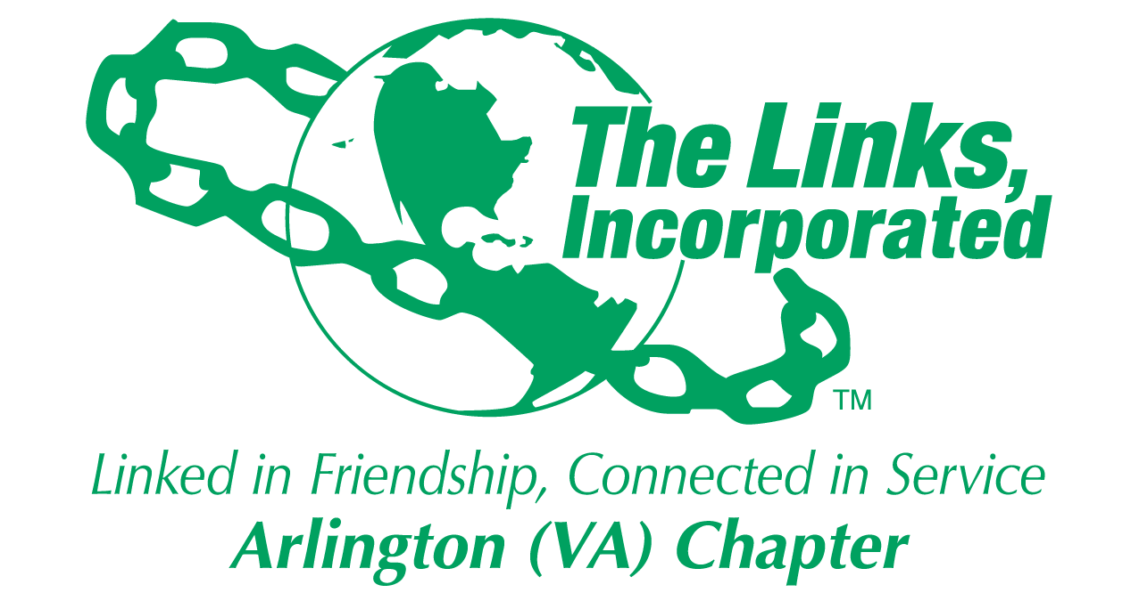

Arlington (VA) Chapter
The Links, Incorporated
Chapter Meeting
Saturday, October 11, 2025

Minutes

Call to Order: The Arlington (VA) Chapter Meeting was called to order at 11:02 a.m. on October 11, 2025, and recessed until 11:28 when a quorum was established. Link Tameka Tunsil, Chapter President, presided, and Link Yvette Darnaby, captured the meeting minutes.

Quorum: At 11:28 a.m. Link Yvette informed Link Tameka that there were 37 members in attendance. Link Tameka affirmed the quorum and called the meeting to order at 11:28 a.m.

Links Pledge: The Chapter attendees recited the Pledge.

The National Song: The Chapter attendees sang The National Song.

Linkspiration: Link Cheryl Coleman Hall spoke on the theme What’s on Your Mind? citing Philippians 4:7 and encouraging everyone to pray and lean on God in every situation.

Welcome: Link Tameka welcomed everyone to the October Chapter meeting.

Guest: Link Tiffany Lewis, Greater New York Chapter.

Adoption of the Agenda: Without objection, the agenda was adopted as presented.

Approval of the Minutes: Without objection, the Chapter meeting minutes for the September 13, 2025, meeting were adopted as presented.

Birthday Acknowledgment: Link Tameka extended a Happy Birthday greeting to everyone celebrating a birthday in October. Members born in October were asked to stand, and the Chapter sang the Happy Birthday song.

Officer Reports

President’s Report – Link Tameka Tunsil
- Link Lisa’s Listening Wednesdays held on the 2nd Wednesday of the month.
- Black Family Wellness, March 21, 2026
- National Assembly, June 24 to June 27, 2026, Detroit, Michigan
- EA Conference, March 31 – April 4, 2027, Buffalo, NY
- EA Travel – Nashville, TN, November 14 -16, limited slots available.
- The Eastern Area will introduce a Crisis Preparedness Committee, each Chapter must identify a POC to serve on the committee.
- Chapter meeting location changes:
  - October and November 2025, Patrick Henry Elementary School
  - January 2026 through June 2026, Nannie J. Lee Center.
- The EA has imposed a moratorium on all chapter boundary requests.

Vice President’s Report – Link Theresa Peterson
- The use of AI Tools is not approved for use by the Links organization.
- Update your hours in Track It Forward – emails have been sent to members who have not uploaded any hours in the electronic system.
- November Friendship month activity– Movie screening of Wicked: For Good, on November 23, 2025, at AMC Shirlington. Date and time will be sent via the Weekly Correspondence.
- Link Felicia Phillips Welch is ill, please keep her in your prayers.

Core Value: Responsibility/Accountability

Current Membership: 78
Active: 72 | Leave of Absence: 4
Platinum: 4 | Pending Transfers: Out: 0
PNP: 1 | Recent Transfer In: 0
Dual Members (P): 2 | LOA Requests: 0
Dual Members (S): 2 | DOLs: 21

Motion
- The Executive Committee voted to approve the Membership Committee’s recommendation not to conduct membership intake during the 2025 – 2026 program year.
- The motion was brought to the Chapter for voting.
- Without objection, the motion passed by voice vote.

Financial Secretary’s Report – Link Caroline Lang: A report was provided.

Treasurer’s Report – Link Francine Lane: A report was provided.

Recording Secretary’s Report – Link Yvette Darnaby:
- The QR Code sign-in process has been replaced. All members must see the Recording Secretary to sign in to the monthly Chapter Meeting.

Corresponding Secretary’s Report – Link Michelle Bailey
- The Chapter pictorial directory will be issued this month.
- Contact Link Michelle Bailey if you are not receiving the weekly correspondence.
- Review the Chapter’s Contact List for accuracy.

Parliamentarian’s Report – Link Angela Foster
- Proposed amendments for the 45th National Assembly submission deadlines:
  - December 15, 2025 – The Links Incorporated Constitution
  - February 8, 2026 – The Links Incorporated Bylaws
  - March 15, 2026 – The Links Foundation, Incorporated Bylaws

Standing Committee Reports:

Programs –Link Hope Goins
- The Chapter held a successful virtual Walk for Healthy Living program on September 27, 2025. Chapter members should continue to upload steps into the electronic system.
- The Arts - EA Unheard No More, is a health advocacy book that will be a collection of shared health experiences.
- October 21, 2025 – Link Hope will be a presenter on the Program Delivery Model Webinar this month.

STY - Link Chevette Mooney
- STEAM Plus
  - Theme: Exploring with Power and Possibility
  - Dates/Location/Time: November 22, 2024, and January 24, 2026, Nannie Lee Center, 10 a.m. to 2:00 p.m. (setup at 9:00 a.m.)
  - Send $25 maximum gift card donations/prizes to Link Lynn and Link Melandee.

NSBE Jr. – Link Rachel English
- The Chartering Ceremony for the Community Partnership Program of the Mount Zion Baptist Church Future Engineers, NSBE Jr. Chapter was held on Sunday, September 28th.
- The Chapter has three active NSBE Jr. Chapters. Chapter member support is needed before, after, and during the monthly NSBE Jr. Chapter meetings.
- NSBE Jr. meeting times and locations will be provided in the upcoming Weekly Correspondence.

NTS – Link Cheryl Coleman Hall, Link Krysta Jones, and Link Tamara Nall
- October 28th – National Vote Early Day
- November 3rd – National Election Hero Day
- November 4th – Election Day
- Eastern Area Buy Black Initiative – Chapters are encouraged to support black owned businesses and efforts. Send success stories of African American community members and activities to Link Cheryl. Input will be published in the EA Update monthly.

ITS – Link Tammie Smiley and Link Tycely Williams
- The Chapter will partner with the Potomac (VA) Chapter on the Black Professionals in International Affairs 2026 Madam Ambassador Program.

HHS – Link Angel Jacobs
- A virtual DMV Walk-A-Thon was held September 27th. Participants are asked to enter their daily step count into the portal.
- November 1st – Health walk to support the American Heart Association on the mall to raise money and have fun.

Social Committee – Link Julia Pollard
- The Social Committee recommended that the Chapter host a Holiday Social on December 13th at the Hilton Mark Center, from 11:30 a.m. to 3:30 p.m.
  - Fees: Chapter Members $85 and Guests $100
  - Required attendance: 200 (40 Chapter members and 160 guests)

Motion
- Link Wendy Bostic moved that the Chapter host a Holiday Social on December 13th at the Hilton Mark Center.
- The motion received a second.
- The motion passed (22 voting YES and six voting NO).

Red Dress – Link Michelle Bailey and Link Michelle Jones
- Program Dates: February 6 – 8, 2026

Ethics – Link Melandee Jones
- Mandatory, Annual Ethics Webinar - October 30th, and November 20, 2025, at 9:00 p.m.

HBCU – Link Janice Welburn, Link Arkena Dailey, and Link Tamara Nall
- Resume Workshop at UDC on November 10, 2025
- Dress for Success at UDC will be held in February 2026
- Volunteers needed for both events.

The meeting adjourned at 1:08 p.m.

Link Yvette Darnaby
Recording Secretary
Date Approved: TBD

