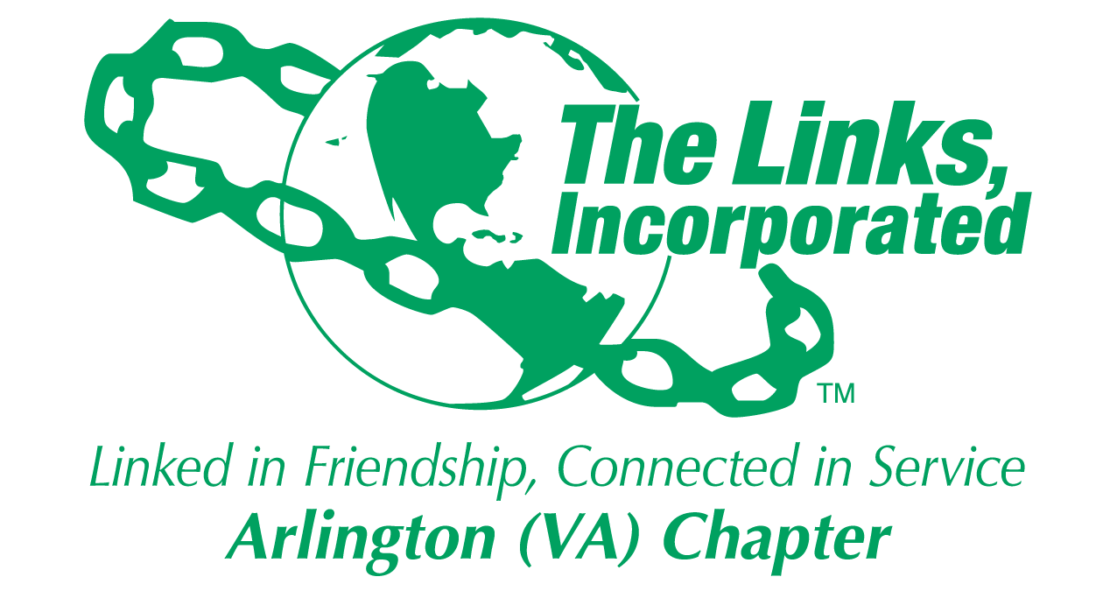

Arlington (VA) Chapter
The Links, Incorporated
Chapter Meeting
Saturday, October 11, 2025

Minutes

Call to Order: The Arlington (VA) Chapter Meeting was called to order at 11:04 a.m. on November 8, 2025, and recessed until 11:13 am when a quorum was established. Link Tameka Tunsil, Chapter President, presided, and Link Yvette Darnaby, captured the meeting minutes.

Quorum: At 11:15 a.m. Link Yvette informed Link Tameka that there were 37 members in attendance. Link Tameka affirmed the quorum and called the meeting to order at 11:13 a.m.

Rituals Committee: Arkena Dailey
- Founder’s Day Litany

Links Pledge: The Chapter attendees recited the Pledge.

The National Song: The Chapter attendees sang The National Song.

Linkspiration: Link Cheryl Coleman Hall
Give thanks in all circumstances give thanks

Welcome: Link Tameka welcomed everyone to the November Chapter meeting.

Guest: Link Alexia Ward Hudson, Link Tracy Jackson, Link Michelle Mason

Adoption of the Agenda: Without objection, the agenda was adopted as presented.
STY NTS ITS,

Approval of the Minutes: Without objection, the Chapter meeting minutes for the October 11, 2025, meeting were adopted as presented.

Birthday Acknowledgment: Link Tameka extended a Happy Birthday greeting to everyone celebrating a birthday in November. Members born in November were asked to stand, and the Chapter sang the Happy Birthday song.

Officer Reports

President’s Report – Link Tameka Tunsil
- Veterans Day acknowledgement
- Virtual founders’ day – please register
- Northern Chesapeake Bay new chapter chartered
- Assembly dates

EA frame please use it during friendship month
Nikki Diane Harley and Kim Campbell Young crisis preparedness committee
- Chapter meeting location changes:
January 2026 through June 2026, Nannie J. Lee Center.
- STEAM and Community Service Project

- Contact Link Melandee Jones if you are unable to attend Ethics Training.
- The Black Family Wellness event will be held on March 21, 2026.
- Signup to attend the virtual Founder’s Day and Friendship Celebration.
- The Chapter photo will take place at the January Chapter meeting.

Vice President’s Report – Link Theresa Peterson

Current Membership: 78
Active: 74 | Leave of Absence: 4
Platinum: 4 | Pending Transfers: Out: 0
PNP: 1 | Recent Transfer In: 0
Dual Members (P): 2 | LOA Requests: 0
Dual Members (S): 1 | DOLs: 21

Friendship month activity: wicked at Hoffman
One service hour for both STEAM and Furloughed empoyees
Gift card for STY: 1 s
Community outreach – other link service activity note: community service for furloughed employees

Hostess for January through June need hosteses

Motion:
- The Membership Committee moved that the Chapter excuse Link Felecia Phillips-Welch meeting attendance due to treatment from the October 11 and November 8, 2025 Chapter meeting.
- The motion passed and no opposition.

Links foundation virtual meeting – 2.5 hours
Ethics standard 1 hour November 20 next trng

Core Value: Friendship

Recording Secretary’s Report – Link Yvette Darnaby: chapter attendance

Financial Secretary’s Report – Link Caroline Lang: A report was provided.

Treasurer’s Report – Link Francine Lane: A report was provided.

Parliamentarian – Link Angela Foster: No Report

Corresponding Secretary’s Report– Link Michelle Bailey: No Report

Standing Committee Reports:

Programs –Link Hope Goins:
- Chapter members are asked to donate $25 gift cards for families in need within the community. Donated funds will be dispersed amongst the Chapter’s community partners within Alexandria and Arlington. One-hundred percent Chapter participation is requested.

STY - Link Chevette Mooney: STEAM Plus program dates:
- Lee center setup at 10 session begins at 11am
- Donations and fail to coordinate with another link chapter – see link Chevette
- Donations – need more contributions from corporations
- Need a planning session with facet chairs - virtual
- November 22, 2024, and January 24, 2026
- Send $25 maximum gift card donations/prizes to Link Lynn and Link Melandee.

NTS – Link Cheryl Coleman Hall, Link Krysta Jones, and Link Tamara Nall
- Buy Black Initiative – Support black owned businesses and efforts throughout the month of November.
Next meeting November 13th
AI and the governance
VA black business directory
Ea align chapter program with EA
Hightlihgh black business through the weekly correspondence

ITS – Link Tammie Smiley and Link Tycely Williams
- The committee is working to refine the Black Professionals in International Affairs 2026 Madam Ambassador Program Schedule.
- Money to steam and madam ambassador program allocated money
- Metro dc will partner with chapter on madam ambassador program

HHS – Link Angell Jacobs
- The Black Family Wellness event will be held on March 21, 2026.

The Arts – Link Aleta Johnson and Link Brenda Martin:
- The submission deadline to contribute stories for the “Unheard No More” health advocacy book is December 25, 2025.

Ethics – Link Melandee Jones
- National Ethics and Standards Training will be held on November 20, 2025.
- Members must complete the attestation form in MMS to satisfy this annual requirement.

Social Committee – Link Julia Pollard
- The Holiday Party will be held on December 13th at the Hilton Mark Center.
- Tickets: Chapter Members $85; Guests $100
- Self-Parking: $18
- Eventbrite link up and running or Zelle to the chapter
- Brunch items

Community Partnership: Link Brenda Martin
- No community partnership awards at the holiday party
- Working to improve application process for community partnership awards

Red Dress – Link Michelle Bailey and Link Michelle Jones: No Report

HBCU –Link Janice Welburn, Link Arkena Dailey and Link Tamara Nall
- Please continue to support the Eastern Area, HBCU Capital Campaign in partnership with the Thurgood Marshall College Fund. The goal is to achieve one hundred percent Chapter participation.
- Need volunteers to work booth from 8:30am to 4pm – register at Alfred street website. Use signup genies – November 15th

Strategic Planning Committee – Link Evie Brown
- Efforts are underway to get Chapter activities and events aligned with the strategic plan.
- New cycle started in 2025 to 2030 – next five years

Diamond Jubilee – Link Michelle Jones
- Proposed date: November 19, 2026

Announcements
- Thank you, November hostesses!
- RSVP to Chapter meeting for logistics and hostesses to plan
- Special gift from hostess committee to Chapter
- Link Michelle Jones’s father was impacted by the hurricane that decimated Jamaica. Please keep the Jones family and all impacted by the hurricane in your prayers.
- Thank you card from Link Karen Hughes
- Fashion Show – Strut the runway
- All students from DMV may participate
- Crisis preopardness – ea want to put together a directory connections with job searching or head hunters, emotionall support etc emainl nikki martin
- 2nd Sunday doner sabbath Sunday- metropolitan 1518 nw
- Raffle for gifts

The meeting adjourned at 1: 16 p.m.

Link Yvette Darnaby
Recording Secretary
Date Approved: TBD

