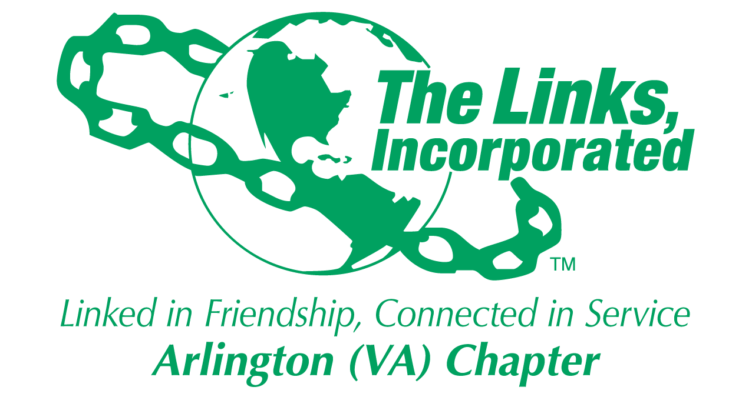

Arlington (VA) Chapter
The Links, Incorporated
Chapter Meeting
Saturday, January 10, 2026

Minutes

Call to Order: The Arlington (VA) Chapter Meeting was called to order at 11:00 a.m. on January 10, 2026, and recessed until 11:14 a.m. when a quorum was established. Link Theresa Peterson, Chapter Vice President, presided, and Link Yvette Darnaby, Recording Secretary, recorded the meeting minutes.

Quorum: At 11:14 a.m. Link Yvette informed Link Theresa that there were thirty-eight members in attendance. Link Theresa affirmed the quorum and called the meeting to order at 11:22 a.m.

Links Pledge: The Chapter attendees recited the Pledge.

The National Song: The Chapter attendees sang The National Song.

Linkspiration: Link Cheryl Coleman Hall – spoke on the subject Think.

Birthday Acknowledgment: Link Theresa extended birthday greetings to everyone celebrating a birthday in January. Members born in January were asked to stand.

Welcome: Link Theresa extended friendship greetings and welcomed everyone to the January Chapter meeting.

Guest: Link Carol Rountree

Approval of the Minutes: The Chapter meeting minutes for November 8, 2025, were adopted as presented.

Adoption of the Agenda: In Link Angela Foster’s absence, Link Theresa appointed Link Michelle Jones as the Parliamentarian for the meeting. The agenda was updated and adopted without objection.

Officer Reports

President’s Report – Link Tameka Tunsil
- In Link Tameka’s absence Link Theresa Peterson delivered the President’s Report.
- Save the Date:
  - Ethics Webinar – The last chance to attend the webinar is January 11, 2026, at 8pm. Contact Link Melandee Jones if you are unable to attend.
  - National Assembly, June 24 – 28, 2026, Detroit, Michigan.
  - Link Lisa’s Listening Wednesdays – 2nd Wednesday of each month.
  - “Unheard No More” submission deadline extended to January 30, 2026.
- Chapter meeting location - Jan 2026 - Jun 2026, Nannie J. Lee Center
- New Transfers - Link Tiffany Johnson Lewis and Link Michelle Mason extended greetings and introduced themselves to the Chapter.

Social Committee /60th Anniversary – Link Julia Pollard and Link Michelle Jones
- Link Michelle Jones read the recommendation approved by the Executive Committee.
Recommendation: By ballot, Chapter members were asked to vote for one of two options.
    - Option #1: Proceed with a small-scale observance of the 60th Anniversary, to be funded through a separate assessment to be determined and approved by the Chapter; or
    - Option #2: Combine the 60th Anniversary celebration with the Monte Carlo 2027 event and plan a joint celebration in 2027.

- Link Theresa called for discussion and placed a ten-minute limit on discussion.
- Following discussion, a printed ballot was distributed, and Chapter members voted.
- Forty-nine votes were cast.
- Fourteen members voted for Option #1.
- Thirty-four members voted for Option #2.
- Option #2 passed and the Chapter will observe the 60th Anniversary during Monte Carlo 2027.

Vice President’s Report – Link Theresa Peterson

- Link Yvette Darnaby informed Link Theresa that the National Chapter Roster shows 80 active Chapter members. Link Theresa will work to resolve the discrepancy in the reporting.

Current Membership: 79 (discrepancy)
Active: 75 | Leave of Absence: 4
Platinum: 4 | Pending Transfers: Out: 0
PNP: 1 | Recent Transfer In: 1
Dual Members (P): 2 | LOA Requests: 0
Dual Members (S): 1 | DOLs: 21

- Link Tamara Nall is out on medical leave and plans to request a medical leave of absence.
- Link Melandee Jones and Link LaJuanna Russell are planning a global wine tasking event to be held following the April 11, 2026, Chapter meeting.
- Manage your own membership – Notices have gone out to members who have not entered any hours in the electronic portal.
- Chapter survey – All members are encouraged to complete the survey.
- Link Theresa is considering working with a facilitator to determine why members are not supporting Chapter events.

Core Value: Confidentiality

Financial Secretary’s Report – Link Caroline Lang: A report was provided.

Treasurer’s Report – Link Francine Lane: A report was provided.
- Link Francine led the Budget review.
- National Dues: $350 due between February 15th and March 16th
- Meal Assessment: $187 due by September 2026
- Three options for Chapter dues were presented
- The Chapter will vote on the 2026 -2027 program year budget at the February Chapter meeting.
- Chapter members were asked to send budget questions to the Recording Secretary.

Due to time constrains, Link Theresa asked that only committee reports that require action be presented.

Recording Secretary’s Report – Link Yvette Darnaby: No report
- none

Corresponding Secretary – Link Michelle Bailey: No report

Standing Committee Reports:

Programs –Link Hope Goins: No report

STY - Link Chevette Mooney
- The next STEAM Plus program will be held on January 24, 2026, at the Nannie J. Lee Center.
- Gift card donations are still being accepted.

NSBE Jr. – Link Rachel English: No report

NTS – Link Cheryl Coleman Hall, Link Krysta Jones, and Link Tamara Nall: No report

ITS – Link Tammie Smiley and Link Tycely Williams
- The Committee will host a joint dress for success event on March 2, 2026. Link Yolanda Holmes will conduct a skin care demo.

HHS – Link Angell Jacobs and Link Lajuana Russell
- The committee secured an INOVA sponsor for the Black Family Wellness program. The Black Family Wellness program will be held on March 21, 2026.

The Arts – Link Aleta Johnson and Link Sandra Clark: No report

Community Partners – Link Brenda Martin
- The grant application is ready for distribution. The deadline to return completed applications is February 19, 2026. The committee has $30k to award.

Ethics – Link Melandee Jones
- Ethics Webinar – The last chance to attend the webinar is January 11, 2026, at 8:00p.m. Contact Link Melandee if you are unable to attend.

Red Dress – Link Michelle Bailey and Link Lavern Chatman
- Dates: February 6 - 8, 2026
- Theme: “Ladies First”
- Red Dress Sunday will be held at Kingdom Fellowship A.M.E. Church
- Volunteers are needed!

HBCU – Link Janice Welburn, Link Akena Dailey, and Link Tamara Nall
- Following the Chapter meeting, the committee will meet at Link Francine’s home to assemble hygiene packages for students attending UDC.

Strategic Planning Committee – Link Evie Brown: No report

ISCC – Link Yvette Darnaby: No report

Announcements
- Link Michelle Bailey read a thank you card from Link Lucci Gray

Meeting adjourned at 1:20 p.m.

Link Yvette Darnaby
Recording Secretary
Date Approved: TBD

Chapter Attendance
January 10, 2026
First | Last | Status
Aleta | Johnson
Angela | Foster, Esq.
Angell | Jacobs | 1
Anita | Walker | 1
Arkena | Dailey | 1
Ashley | Flakes
Avril Ussery | Sisk | 1
Belinda W. | LaValle
Brenda | Martin, PhD
Bridget Bailey | Lipscomb, Esq. | 1
Candice | Tobin | 1
Caroline | Lang, PhD | 1
Cheran Cordell | Ivery
Cheryl Coleman | Hall | 1
Chevette | Mooney | 1
Dawn | Johnson | 1
Denise E. | Bruner, MD
DeVera Y. | Redmond | 1
Diane | Butts | 1
Diane M. | Harley
Earnestine "Erni" | Bridges Borden
Elaine | Bush+
Elizabeth Jackson | Hodges |  | Meeting Sabbatical
Emily | Bryant | 1
Evelyn "Evie" | Brown | 1
Evelyn E. | Gee | 1
F. Denise Gibson | Bailey | 1
Faith | Blackburne-Proctor
Felecia Y. | Phillips-Welch | 1
Francine | Lane | 1
Heather | Hill | 1
Hope | Goins
Isabelle F. | Fant+
Janice | Welburn | 1
Julia A. | Pollard | 1
Karen | Johnson, Esq. |  | LOA
Karen Jordan | Wright
Karen Peters | Hughes | 1
Karyn | Temple | 1
Kedren | Dillard | 1
Keisha Boggan | Campbell | 1
Kelly | Bolden, MD | 1
Kim Campbell | Young
Kimberly Jeffries | Leonard, PhD**
Kimberly N. Parker | Pinder | 1
Krysta | Jones | 1
LaJuanna | Russell | 1
Lauren | Weaver |  | LOA
Lavern J. | Chatman | 1
Lillie Easley | Parker |  | LOA
Lisa | Gregory, Esq. | 1
Lisa | Lee-Packer
Lori | Stith | 1
Luciana | Gray | 1
Maia | McCuiston, MD |  | Meeting Sabbatical
Marietta S. | Palmer, EdD
Martine | Wilson
Melandee | Jones | 1
Michelle M. | Bailey* | 1
Michelle Marie | Jones | 1
Michelle | Mason | 1
Natasha | Rountree | 1
Nicholette M. | Martin, MD | 1
P. Michele | Ellison | 1
Rachel | English | 1
Rose Williams | Boyd*+ | 1
Sandra Jenkins | Clark | 1
Sudonna | Moss Stevens, Ed.D. | 1
Suzanne | Walker* | 1
Tamara | Nall
Tameka | Tunsil*
Tammie | Smiley | 1
Telesa | Via | 1
Tiffany | Johnson Lewis | 1
Theresa | Peterson* | 1
Traci | Washington |  | LOA
Tycely | Williams
Wendy | Bostic
Yolanda C. | Holmes, MD | 1
Yvette | Darnaby* | 1
 | TOTAL | 51
 | Guest: Link Carol Rountree
 | Link Linda Washington
 | Quorum: 38
 | 80 Active Members

