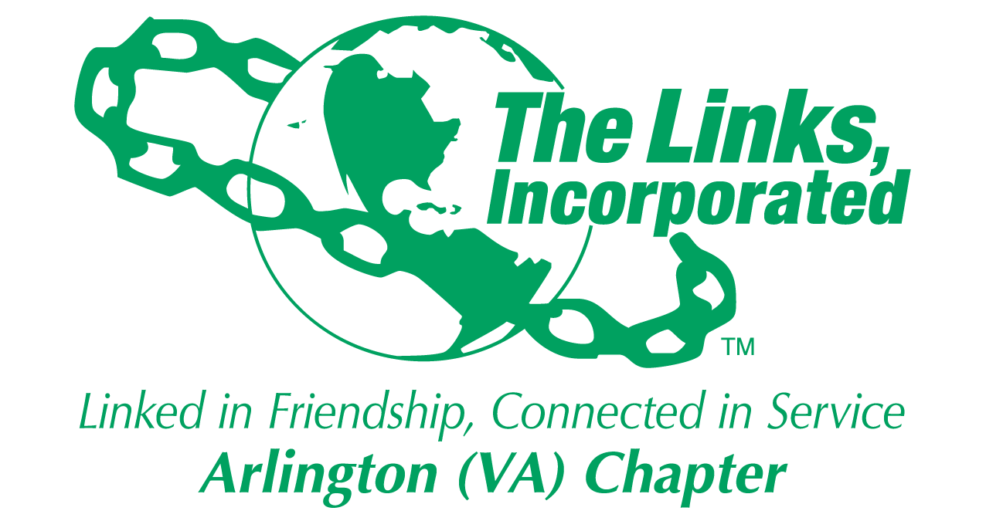

Arlington (VA) Chapter of
The Links, Incorporated
Chapter Meeting
Saturday, February 14, 2026

Minutes

Call to Order: The Arlington (VA) Chapter Meeting was called to order at 11:20 a.m. on February 14, 2026. Link Tameka Tunsil, Chapter President, presided and Link Yvette Darnaby, Recording Secretary recorded the meeting minutes.

Quorum: At 11:23 a.m., Link Lucci Grey notified Link Tameka that 38 members were in attendance. Link Tameka affirmed the quorum and called the meeting to order at 11:23 a.m.

Links Pledge: Chapter attendees recited the Pledge.

The National Song: Chapter attendees sang The National Song.

Birthday Acknowledgment: Link Tameka extended birthday greetings to everyone celebrating a birthday in February. Members born in February were asked to stand while the members sang the birthday song.

Welcome: Link Tameka opened the February chapter meeting by extending friendship greetings, acknowledging Black History Month, and wishing everyone a happy Valentine's Day.

Guest: Link Jasmine Geyea

Approval of the Minutes: The Chapter meeting minutes for January 10, 2026, were adopted as presented.

Adoption of the Agenda: The agenda was adopted as presented.

Officer Reports

President’s Report – Link Tameka Tunsil
- All Chapter members have achieved full compliance by completing the annual ethics requirement.
- The 45th National Assembly, will be held June 24 - 28, 2026, in Detroit, Michigan.
- The Chapter Program Report and Data Sheet were submitted ahead of schedule.
- Join Link Lisa’s Listening Wednesdays, the 2nd Wednesday of each month at 8 p.m.
- The Eastern Area Conference 2027 will be held March 31 - April 4, 2027, in Buffalo, NY.
- The Chapter meeting location from January 2026 thru June 2026 is the Nannie J. Lee Center.
- The scholarship payments for FY 25-26 have not been dispersed to recipients. The
Scholarship Committee recommends that the Chapter authorize a one-time payment of up to $10,000.00 per student. Payment amounts will vary depending on the financial need(s) of each student.

Motion and Amendment
Following discussion, Link Yvette Darnaby made the following motion:

Original Motion: I move that the Chapter pay up to $10,000.00 per student to designated colleges or universities.
The motion was seconded.

After discussion, Link Michelle Jones proposed an amendment to the original motion:

Motion Amendment #1: I move to amend the previous motion to include “by the end of this program year.”

The amendment was seconded.

Following additional discussion, Link Yvette Darnaby read the amended motion as follows:

Motion: I move that the Chapter pay up to $10,000.00 per student to designated colleges or universities and that the funds be dispersed by the end of this program year.

By majority vote, the motion passed.

Vice President’s Report – Link Theresa Peterson

Current Membership: 79
Active: 75 | Leave of Absence: 4
Platinum: 4 | Pending Transfers: Out: 0
PNP: 1 | Recent Transfer In: 0
Dual Members (P): 2 | LOA Requests: 0
Dual Members (S): 1 | DOLs: 22
- Manage Your Membership, use the electronic portal to log service hours, every member must attend five of nine Chapter meetings, and dues must be paid by March 15, 2026.
- If you need service hours, please attend the up-coming HHS events.
- Link Theresa gifted flowers to:
  - Link Francine Lane for her dedicated work on the budget.
  - Platinum Members for their engagement and attendance at Chapter meetings.
  - Link Denise Bruner for upholding a distinguished, multi-generational legacy of Black medical excellence in the Arlington community.
  - Link Jamine Geyea, guest.
- Link Theresa Peterson made the following Leave Action motions:

Motion
- Excused Chapter Meeting Absence for Link Lucci Grey on September 13, 2025, due to death in her family.
- The Chapter voted and, by unanimous consent, approved the request.

- Excused Chapter Meeting Absence for Link Cheron Cordell Ivory on September 13, 2025, March 14, 2026, and June 13, 2026, due to work conflicts. Link Cheron must attend City Council Meetings.
- The Chapter voted and, by unanimous consent, approved the request.

- Leave of Absence for Link Tamara Nall for the remainder of the program year due to illness.
- The Chapter voted and, by unanimous consent, approved the request.
Core Value: Respect
Financial Secretary’s Report – Link Caroline Lang: A report was provided.

Treasurer’s Report – Link Francine Lane: A report was provided.

Recording Secretary’s Report – Link Yvette Darnaby: No Report

Corresponding Secretary – Link Michelle Bailey: No Report

Parliamentarian - Angela Foster
- Link Angela shared through music and dialogue the four actions to take when you don’t have a quorum at a Chapter meeting.

Budget Committee Report: Link Francie Lane
- Link Francie reported a funding shortfall for the 2025 Holiday Social, necessitating a financial assessment. The Budget Committee will present recommended actions to address this deficit at the March Chapter meeting.
- Copies of the Operating and Restricted Budgets were disseminated.
- Link Francine provided a detailed, line-by-line overview of the Operating and Restricted Budget Accounts and explained how to use the colored voting cards to vote for preferred meeting venue options.
- Four meeting venue options were presented; Option #2 was withdrawn due to limited availability during the program year. Note: The Hilton is only available for three meetings.

  - Option #1: Lee Center w/Baby Chef
  - Option #2: Hilton
  - Option #3: Westin Carlye
  - Option #4: Lee Center w/No Food

- Following extensive discussion, Link Tammie Smiley made the following Motion:

Motion:
- I move to use the voting cards to make the selection of the meeting location, and that the chapter supports the decision of the majority.
- The motion was seconded.
- The Chapter voted:
Option #1- Lee Center w/Baby Chef: 10 votes
Option #3 - Westin Carlye: 17 votes
Option #4 - Lee Center/No Food: 19 votes
- Link Tameka stated the out of the vote as Option #4 Lee Center/No Food.
  - National Dues $350.00; Chapter Dues $555.00; and Venue $144.00
  - Total Due by March 15, 2026, $1049.00

- A Zoom call will be arranged to discuss the Operating and Restricted Budgets.

Announcements
- The Crisis and Preparedness Committee is currently developing a Chapter Directory and will present a Stop the Bleed Workshop and an Active Shooter Workshop. See Link Nikki Martin for details.
- The Arts Facet will travel by train on March 25, 2026, to the Baltimore Museum of Art to see the Amy Sherald collection. The cost is $20.00 per person. See Link Aleta Johnson for details.
- ITS Facet will host a Dress for Success Workshop on March 7, 2026. Dr. Yoland Holmes will conduct a skin care workshop. See Link Tammie Smiley for details.
- HHS Facet - Chapter members seeking service hours are encouraged to support the Feel the Heritage Festival, February 21, 2026, and the Black Family Wellness event, March 21, 20026 at the Drew Community Center. See Link Angell Jacobs for details.

- A raffle was held, and prizes were awarded.

The meeting adjourned at 2:05 p.m.

Link Yvette Darnaby
Recording Secretary
Date Approved: TBD

Chapter Meeting Attendance
February 14, 2026
First | Last | Status
Aleta | Johnson | 1
Angela | Foster, Esq. | 1
Angell | Jacobs | 1
Anita | Walker | 1
Arkena | Dailey
Ashley | Flakes | 1
Avril Ussery | Sisk | 1
Belinda W. | LaValle
Brenda | Martin, PhD | 1
Bridget Bailey | Lipscomb, Esq. | 1
Candice | Tobin
Caroline | Lang, PhD | 1
Cheran Cordell | Ivery | 1
Cheryl Coleman | Hall | 1
Chevette | Mooney | 1
Dawn | Johnson
Denise E. | Bruner, MD | 1
DeVera Y. | Redmond | 1
Diane | Butts
Diane M. | Harley
Earnestine "Erni" | Bridges Borden
Elaine | Bush+ | 1
Elizabeth Jackson | Hodges |  | Meeting Sabbatical
Emily | Bryant | 1
Evelyn "Evie" | Brown | 1
Evelyn E. | Gee
F. Denise Gibson | Bailey
Faith | Blackburne-Proctor | 1
Felecia Y. | Phillips-Welch | 1
Francine | Lane | 1
Heather | Hill | 1
Hope | Goins | 1
Isabelle F. | Fant+
Janice | Welburn
Julia A. | Pollard
Karen | Johnson, Esq. |  | LOA
Karen Jordan | Wright
Karen Peters | Hughes
Karyn | Temple | 1
Kedren | Dillard | 1
Keisha Boggan | Campbell
Kelly | Bolden, MD
Kim Campbell | Young
Kimberly Jeffries | Leonard, PhD**
Kimberly N. Parker | Pinder
Krysta | Jones | 1
LaJuanna | Russell | 1
Lauren | Weaver |  | LOA
Lavern J. | Chatman
Lillie Easley | Parker |  | LOA
Lisa | Gregory, Esq. | 1
Lisa | Lee-Packer
Lori | Stith | 1
Luciana | Gray | 1
Maia | McCuiston, MD |  | Meeting Sabbatical
Marietta S. | Palmer, EdD | 1
Martine | Wilson | 1
Melandee | Jones | 1
Michelle M. | Bailey*
Michelle Marie | Jones | 1
Michelle | Mason
Natasha | Rountree | 1
Nicholette M. | Martin, MD | 1
P. Michele | Ellison | 1
Rachel | English | 1
Rose Williams | Boyd*+ | 1
Sandra Jenkins | Clark | 1
Sudonna | Moss Stevens, Ed.D. | 1
Suzanne | Walker* | 1
Tamara | Nall
Tameka | Tunsil* | 1
Tammie | Smiley | 1
Telesa | Via | 1
Tiffany | Johnson Lewis
Theresa | Peterson* | 1
Traci | Washington |  | LOA
Tycely | Williams
Wendy | Bostic
Yolanda C. | Holmes, MD | 1
Yvette | Darnaby* | 1
 | TOTAL | 47
 | Guest:
 | Link Linda Washington
 | Link Jasmine Geyea
 | Present: 1
 | Quorum: 38

