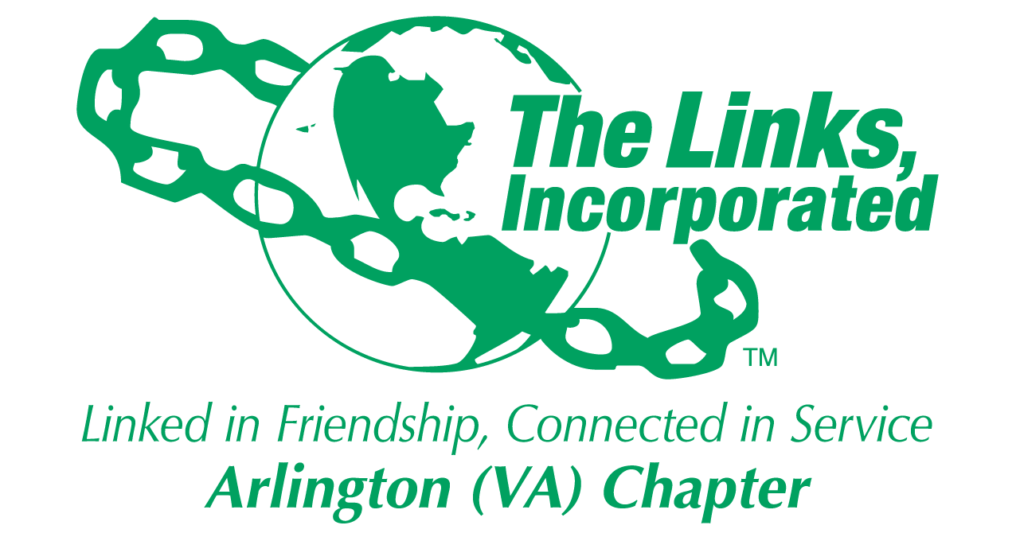

Arlington (VA) Chapter of
The Links, Incorporated
Chapter Meeting
Saturday, April 11, 2026

Minutes

Call to Order: The Arlington (VA) Chapter Meeting was called to order at 11:12 a.m. on April 11, 2026
Link Tameka Tunsil, Chapter President, presided, and Link Yvette Darnaby recorded the meeting minutes.

Links Pledge: Chapter attendees recited the Pledge.

The National Song: Chapter attendees sang The National Song.

Linkspiration: Link Cheryl Coleman Hall

Birthday Acknowledgment: Link Tameka extended birthday greetings to everyone celebrating a birthday in April. Members born in April were asked to stand while the members sang the birthday song.

Announcements (part 1)
- Link Tameka read a membership resignation letter submitted by Link Lauren Weaver.
- Link Lavern Chatman announced that she and Link Theresa Peterson will serve as Chairs for Monte Carlo 2027. Link Tammie Smiley and Link LaJuanna Russell will serve as Co-Chairs. This event will incorporate the celebration of the Chapter’s 60th Anniversary.
- Link Suzanne announced that the Golf Classic will be held on June 15, 2026, at the Westfields Golf Course. The committee seeks golfers, sponsors and volunteers.

A raffle was held, and prizes were awarded.

Quorum: At 12:04 p.m., Link Yvette notified Link Tameka that 39 members were in attendance. Link Tameka affirmed the quorum and called the meeting to order at 12:04 p.m.

Welcome: Link Tameka extended greetings to everyone.

Adoption of the Agenda: The agenda was revised to eliminate reports not requiring action by the Chapter.

Approval of the Minutes: The Chapter meeting minutes for March 14, 2026, were adopted as presented.

Officer Reports

President’s Report – Link Tameka Tunsil
- Link Elaine Bush and Link Ernie Bridges are now alumnae members.
- The 45th National Assembly, will be held June 24 - 28, 2026, in Detroit, Michigan.
- The Eastern Area App is now available in the App store
- Join Link Lisa’s Listening Wednesdays, the 2nd Wednesday of each month at 8 p.m.
- The Eastern Area Conference 2027 will be held March 31 - April 4, 2027, in Buffalo, NY.
- 17th Kirk Bown Golf Tournament will be held June 15th
- Link Tameka recognized Link Theresa Peterson for her support throughout the program year.

Vice President’s Report – Link Theresa Peterson
Current Membership: 80
Active: 75 | Leave of Absence: 4
Platinum: 4 | Pending Transfers: Out: 0
PNP: 1 | DOLs: 22
Dual Members (P): 2
Dual Members (S): 1

- Link Theresa presented three Leave Requests for the 2026–2027 program year.
  - Medical Leave: The Chapter unanimously approved medical leave requests for Link Maia McCuiston and Link Tamara Nall.
- Meeting Sabbatical: The Chapter unanimously approved the meeting sabbatical request for Link Kimberly Parker Pinder.

Financial Secretary’s Report – Link Caroline Lang: A report was provided.

Treasurer’s Report – Link Francine Lane: A report was provided.

Recording Secretary’s Report – Link Yvette Darnaby: No Report

Parliamentarian – Link Angela Foster: No Report

Corresponding Secretary – Link Michelle Bailey: No Report

Standing Committee Reports:

Programs –Link Hope Goins
- Link Hope will meet with Chapter leadership to discuss program direction for the upcoming program year.

STY - Link Chevette Mooney: No Report

NTS – Link Cheryl Coleman Hall, Link Krysta Jones, and Link Tamara Nall: No Report

ITS – Link Tammie Smiley and Link Tycely Williams
- Link Tycely invited the Chapter to high tea with the Madam Ambassador participants on Friday, May 8, 2026. The cost is $45.00 per person.

HHS – Link Angell Jacobs and Link LaJuanna Russell
- Link LaJuanna provided remarks and thanked the Chapter for supporting the Black Family Wellness Expo and the Feel the Heritage Festival.

The Arts – Link Aleta Johnson and Link Sandra Clark: No Report

Rituals – Link Arkena L. Dailey: No Report

Community Partners – Link Brenda Martin
- Ten organizations were selected to receive a grant award. Julius Spain, Sr. Arlington County Board Member announced the award winners during the Black Family Wellness Expo. $30k given away

Golf Committee – Link Suzanne Walker, Link Kedren Dilliard and Link Faith Blackburne: No report

Announcements (part two)
- Link Aleta shared that Link Lisa Gregory had an art piece on loan to the Amy Sherald exhibition when it was in Baltimore.
- Link LaJuanna announced that her daughter will receive her master’s degree next month.
- Link Tycely shared that her nice will attend the American Ballet summer intensive program.
- Link Lavern presented the book Mr. Secretary: From the Potato Fields to the White House, authored by Connecting Link Wilbert Bryant, Link Emily Bryant’s husband.

The meeting adjourned at 12:52 p.m.

Link Yvette Darnaby
Recording Secretary
Date Approved: TBD

