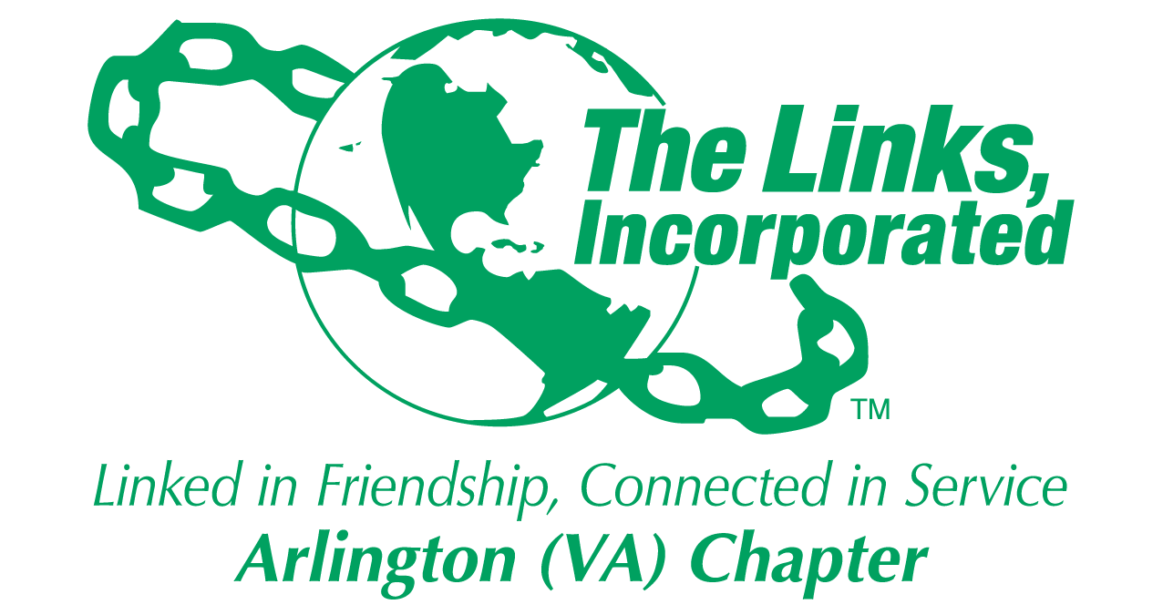

Arlington (VA) Chapter of
The Links, Incorporated
Chapter Meeting
Saturday, March 14, 2026

Minutes

Call to Order: The Arlington (VA) Chapter Meeting was called to order at 11:25 a.m. on March 14, 2026. Link Tameka Tunsil, Chapter President, presided and Link Lucci Gray, recorded the meeting minutes.

Quorum: At 11:25a.m., Link Janice Welburn notified Link Tameka that 39 members were in attendance. Link Tameka affirmed the quorum and called the meeting to order at 11:25 a.m.

Links Pledge: Chapter attendees recited the Pledge.

The National Song: Chapter attendees sang The National Song.

Birthday Acknowledgment: Link Tameka extended birthday greetings to everyone celebrating a birthday in March. Members born in March were asked to stand while the members sang the birthday song.

Welcome: Link Tameka extended friendship greetings, acknowledged Women’s History Month and read the Linkspiration on behalf of Link Cheryl Coleman Hall who was absent.

Adoption of the Agenda: The agenda was adopted as presented.

Approval of the Minutes: The Chapter meeting minutes for February 14, 2026, were adopted as presented.

Officer Reports

President’s Report – Link Tameka Tunsil
- Link Tameka participated in a special call meeting with the National President to discuss a recent DEI article. The National President suggested that all chapters promoting the Black Family Wellness Expo add a statement that communicates openness and all are welcome to the event.
- The 45th National Assembly, will be held June 24 - 28, 2026, in Detroit, Michigan.
- Join Link Lisa’s Listening Wednesdays, the 2nd Wednesday of each month at 8 p.m.
- The Eastern Area Conference 2027 will be held March 31 - April 4, 2027, in Buffalo, NY.
- Black Family Wellness Expo - March 21st, at Charles Drew Community Center
- The 17th Annual Kirk Bowden Golf Tournament will be held June 15th.

Vice President’s Report – Link Theresa Peterson

Current Membership: 80
Active: 75 | Leave of Absence: 4
Platinum: 4 | Pending Transfers: Out: 0
PNP: 1 | Recent Transfer In: 0
Dual Members (P): 2 | LOA Requests: 0
Dual Members (S): 1 | DOLs: 22
- Manage Your Membership, use the electronic portal to log service hours, every member must attend five of nine Chapter meetings, and dues must be paid by March 15, 2026.
Core Value: Courage
- Link LaJuanna Russell will host a wine tasting at her home on Saturday, April 11, 2026.
- Link Michelle Bailey was recognized for her extraordinary support as the Corresponding Secretary.
- Link Lavern Chatman was recognized for her dedication to detail.
- Link Angela Foster was recognized for her role as Parliamentarian.
Financial Secretary’s Report – Link Caroline Lang: A report was provided.

Treasurer’s Report – Link Francine Lane: A report was provided.

Budget Committee Report: Link Francie Lane
- Link Francie reported a funding shortfall for the 2025 Holiday Social, necessitating a financial assessment. The Budget Committee recommended a $50 per chapter member assessment.
- Following extensive discussion Link Luciana Gray made the following motion:

Motion
- I move that the Chapter accept a motion to commit the shortfall expense back to the Budget Committee for action.
- The motion was seconded.
- The Chapter voted and the motion passed:
- Yes: 27
- No: 8

Following discussion regarding the recommended Chapter assessment, Link Luciana Gray made the following motion:

Motion
- I move that we vote by ballot not to assess Chapter members for the 2026 - 2027 program year.
- The motion was seconded.
- The Chapter voted and the motion failed.
  - Yes: 21
  - No: 25
  - Abstention: 2
- Following further discussion, Link Michelle Ellison made the following motion:

Motion
- I move that Chapter members be assessed $375.00 for the 2026 - 2027 program year.
- The motion was seconded.
- The Chapter voted and the motion passed.
  - Yes: 30
  - No: 7

HHS – Link Angell Jacobs and Link Lajuana Russell
- Black Family Wellness Expo - March 21st, Charles Drew Community Center - all hands-on deck needed. Share the event flyer with family and friends.

A raffle was held, and prizes were awarded.

The meeting adjourned at 1:50 p.m.

Link Lucci Gray
Recording Secretary Pro Tem
Date Approved: TBD

