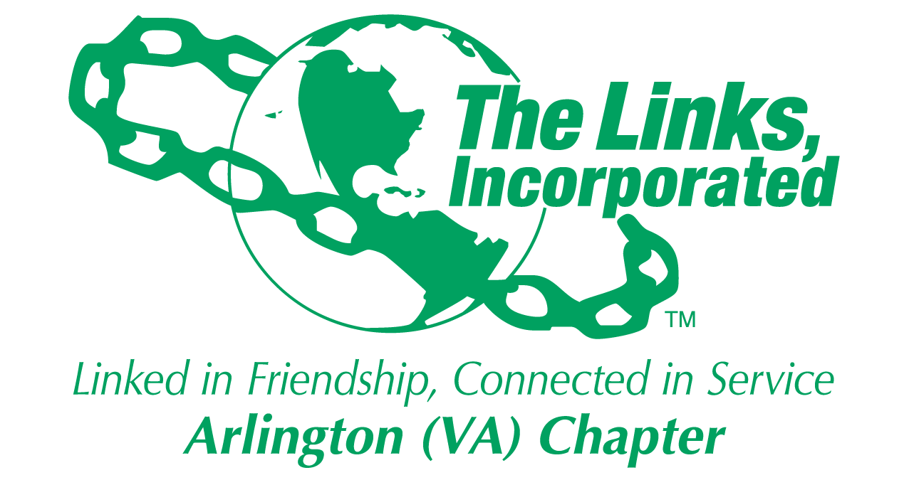

Arlington (VA) Chapter of
The Links, Incorporated
Chapter Meeting
Saturday, May 9, 2026

Minutes

Call to Order: The Arlington (VA) Chapter Meeting was called to order at 11:06 a.m. on May 9, 2026
Link Tameka Tunsil, Chapter President, presided, and Link Yvette Darnaby recorded the meeting minutes.

Links Pledge: Chapter attendees recited the Pledge.

The National Song: Chapter attendees sang The National Song.

Linkspiration: Link Cheryl Coleman Hall spoke about grace.

Birthday Acknowledgment: Link Tameka extended birthday greetings to everyone celebrating a birthday in May. Members born in May were asked to stand while the members sang the birthday song.

Welcome: Link Tameka extended greetings to everyone.

Announcements: Link Yolanda Holmes announced her engagement and her recent move to Baltimore. She plans to transfer her membership to the Baltimore Chapter.

While awaiting a quorum to conduct official business, Link Michelle Jones led the chapter in a game of Links Bingo.

Quorum: At 12:04 p.m., Link Yvette notified Link Tameka that 39 members were in attendance. Link Tameka affirmed the quorum.

Adoption of the Agenda: Link Tameka asked Link Michelle Jones to serve as Parliamentarian for the meeting. The agenda was updated and adopted with the noted amendment.

Approval of the Minutes: The Chapter meeting minutes for April 11, 2024, were adopted as presented.

Officer Reports
President’s Report – Link Tameka Tunsil
- The 45th National Assembly will be held June 24 - 28, 2026, in Detroit, Michigan.
- The Eastern Area App is now available in the App Store.
- Join Link Lisa’s Listening Wednesdays, the 2nd Wednesday of each month at 8p.m.
- The Eastern Area Conference 2027 will be held March 31 - April 4, 2027, in Buffalo, NY.

Vice President’s Report – Link Theresa Peterson

Current Membership: 77
Active: 75 | Leave of Absence: 2
Platinum: 4 | Pending Transfers: Out: 1
PNP: 1 | DOLs: 22
Dual Members (P): 2
Dual Members (S): 1
- The new program year began May 1, 2027. The Track It Forward Portal will close on March 15, 2027. Enter all service hours prior to March 15, 2027.
- In accordance with the Arlington Handbook, page 7, to receive credit for Chapter attendance, members must arrive by 11 a.m. and depart when the meeting is adjourned.
Core Value: Legacy
Financial Secretary’s Report – Link Caroline Lang: A report was provided.

Treasurer’s Report – Link Francine Lane: A report was provided.

Recording Secretary’s Report – Link Yvette Darnaby: No Report

Parliamentarian – Link Angela Foster: No Report

Corresponding Secretary – Link Michelle Bailey: No Report

Standing Committee Reports

Programs –Link Hope Goins:
- Facet activities are undergoing a strategic realignment. All program activities should align with the Chapter’s strategic plan.
- Link Hope will lead the Eastern Area program planning workshop on May 11, 2026.

STY - Link Chevette Mooney: No Report

NSBE Jr. - Link Rachel English: Link Rachel shared a video and photos of the Future Engineers participating in the NSBE Convention held in Baltimore, Md. The Future Engineers, April Chapter Activity Report was selected and is featured on the NSBE Pre-College Initiative Instagram.

NTS – Link Cheryl Coleman Hall, Link Krysta Jones, and Link Tamara Nall: No Report

ITS – Link Tammie Smiley and Link Tycely Williams
- The 2026 Madam Ambassador end-of-year program was held on May 8th at the Army Navy Country Club in Arlington, VA.

HHS – Link Angell Jacobs and Link Lajuana Russell: No Report

The Arts – Link Aleta Johnson and Link Sandra Clark: No Report

Rituals – Link Arkena L. Dailey: No Report

ISCC – Link Yvette Darnaby
- Link Yvette requested a volunteer to attend the unveiling of the new ISCC sign on Monday, May 11, 2026. The sign is located near the Exxon gas station at 6730 Langston Boulevard, Arlington, Virginia.
- Link Julia Pollard and Link Janice Welburn volunteered to represent the Chapter.

Community Partners – Link Brenda Martin: No Report

Monte Carlo 2027 – Link Lavern Chatman, Link Theresa Peterson, Link LaJuanna Russell, and Link Tammie Smiley
- Requests for Proposals have been issued. The committee will present two or three venue proposals to the Chapter for consideration and vote.
- All Chapter members are encouraged to sign up to serve on a committee. Members who do not volunteer for a committee assignment will be assigned to a committee.

Golf Committee – Link Suzanne Walker, Link Kedren Dilliard, and Link Faith Blackburne
- The 17th Annual Kirk Bowden Connecting Link Golf Classic will be held on Monday, June 15, 2026, at the Westfields Golf Club, Clifton, VA.
- Chapter support is needed in three areas: securing sponsors, recruiting golfers, and assisting on the day of the event. Members who plan to support the event will be responsible for paying $46 for their meal.

Announcements
The meeting adjourned at 1:00 p.m.

Chapter Attendance
May 11, 2026
First | Last | Status
Aleta | Johnson
Angela | Foster, Esq.
Angell | Jacobs
Anita | Walker | 1
Arkena | Dailey | 1
Ashley | Flakes | 1
Avril Ussery | Sisk | 1
Belinda W. | LaValle | 1
Brenda | Martin, PhD | 1
Bridget Bailey | Lipscomb, Esq.
Candice | Tobin
Caroline | Lang, PhD* | 1
Cheran Cordell | Ivery
Cheryl Coleman | Hall | 1
Chevette | Mooney | 1
Dawn | Johnson
Denise E. | Bruner, MD | 1
DeVera Y. | Redmond | 1
Diane | Butts
Diane M. | Harley
Elizabeth Jackson | Hodges
Emily | Bryant | 1
Evelyn "Evie" | Brown | 1
Evelyn E. | Gee
F. Denise Gibson | Bailey | 1
Faith | Blackburne-Proctor | 1
Felecia Y. | Phillips-Welch | 1
Francine | Lane* | 1
Heather | Hill | 1
Hope | Goins | 1
Isabelle F. | Fant+
Janice | Welburn | 1
Julia A. | Pollard | 1
Karen | Johnson, Esq.
Karen Jordan | Wright | 1
Karen Peters | Hughes | 1
Karyn | Temple | 1
Kedren | Dillard | 1
Keisha Boggan | Campbell | 1
Kelly | Bolden, MD
Kim Campbell | Young
Kimberly Jeffries | Leonard, PhD
Kimberly N. Parker | Pinder
Krysta | Jones
LaJuanna | Russell | 1
Lavern J. | Chatman | 1
Lillie Easley | Parker
Lisa | Gregory, Esq.
Lisa | Lee-Packer | 1
Lori | Stith
Luciana | Gray | 1
Maia | McCuiston, MD
Marietta S. | Palmer, EdD | 1
Martine | Wilson | 1
Melandee | Jones
Michelle M. | Bailey*
Michelle Marie | Jones | 1
Michelle | Mason
Natasha | Rountree
Nicholette M. | Martin, MD | 1
P. Michele | Ellison
Rachel | English | 1
Rose Williams | Boyd* | 1
Sandra Jenkins | Clark | 1
Sudonna | Moss Stevens, Ed.D.
Suzanne | Walker
Tamara | Nall
Tameka | Tunsil* | 1
Tammie | Smiley | 1
Telesa | Via | 1
Tiffany | Johnson Lewis | 1
Traci | Washington
Theresa | Peterson* | 1
Tycely | Williams
Wendy | Bostic
Yolanda C. | Holmes, MD | 1
Yvette | Darnaby* | 1
 | TOTAL | 44
 | Guest: 0
 | Present: 1

Link Yvette Darnaby
Recording Secretary
Date Approved: TBD

