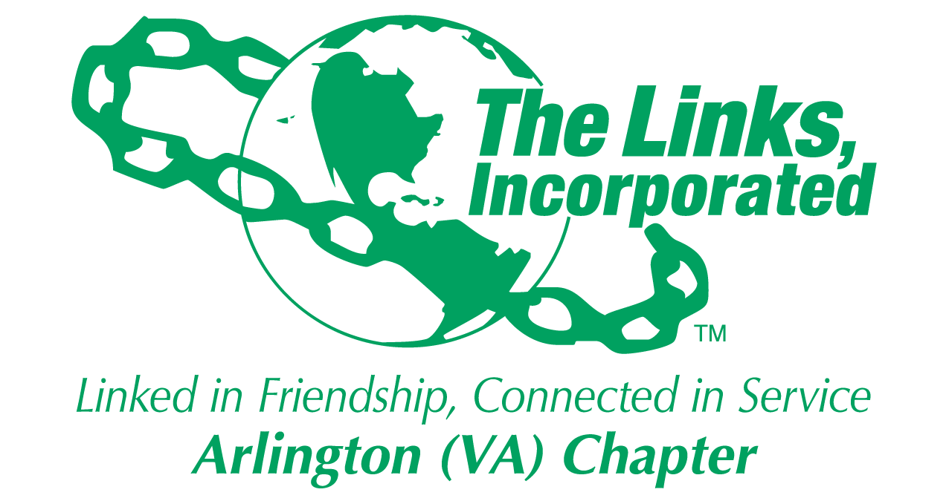

Arlington (VA) Chapter of
The Links, Incorporated
Chapter Meeting
Saturday, June 13, 2026

Minutes

Call to Order: The Arlington (VA) Chapter Meeting was called to order at 11:05 a.m. on June 13, 2026
Link Tameka Tunsil, Chapter President, presided, and Link Yvette Darnaby recorded the meeting minutes.

Links Pledge: Chapter attendees recited the Pledge.

The National Song: Chapter attendees sang The National Song.

Linkspiration: Link Cheryl Coleman Hall spoke about renewal.

Birthday Acknowledgment: Link Tameka extended birthday greetings to everyone celebrating a birthday in June, July and August. Members born in those months were asked to stand while the rest of the members sang the birthday song.

Welcome: Link Tameka extended greetings to all attendees and offered a special welcome back to Link Alexia Hudson-Ward and Link Karen Ford-Johnson.

Golf Informational Report – Link Kedren Dillard
- Twenty-five Chapter members have signed up to volunteer in support of the event.
- Members are encouraged to continue supporting the event by purchasing advertisements and securing sponsorships.
Announcements
- Link Lavern announced that thirty-one Chapter members will attend the National Assembly. A Chapter reception will be held on Friday at 5:30 p.m. Members wishing to contribute toward the reception may send a $15 donation to Link Lavern via Zelle, Venmo, or Cash App.
- Link Hope Goins announced that the Chapter was featured in the June segment of Link Lisa's Listening Wednesday series highlighting maternal health.
- Link Emily and Link Shirley Bowden will be recognized as Platinum Members at the National Assembly. Link Shirley was inducted in the Arlington (VA) Chapter and later transferred to a Maryland Chapter.
- Link Tameka requested prayers for Link Alyce Gaither as she continues her recovery. Link Alyce is not accepting visits however; members may send cards.
Quorum: The meeting was recessed at 11:38 a.m. due to the absence of a quorum. At 11:58 a.m., Link Yvette reported that thirty-six members had signed in, thereby establishing a quorum. Link Tameka announced the presence of a quorum and called the meeting back to order.
Adoption of the Agenda: The agenda was adopted as presented.

Approval of the Minutes: The Chapter meeting minutes for May 9, 2026, were adopted as presented.

Officer Reports

President’s Report – Link Tameka Tunsil
- The 45th National Assembly will be held June 24 - 28, 2026, in Detroit, Michigan. There are 31-chapter members registered to attend. A chapter reception will be held on Friday, June 26, 20026. Chapter members attending the EA Breakfast, are requested to wear the Cedric Brown EA scarf. Delegate meeting June 16th
- The Eastern Area App is now available in the App Store.
- The Leadership Summit will be held October 3 – 4, 2026 at the Gaylord.
- Join Link Lisa’s Listening Wednesdays, the 2nd Wednesday of each month at 8p.m.
- The Eastern Area Conference 2027 will be held March 31 - April 4, 2027, in Buffalo, NY.
- The 17th Kirk Bown Golf Tournament will be held on June 15th
- Happy Anniversary Induction Class of 2019!

Vice President’s Report – Link Theresa Peterson

Current Membership: 76
Active: 75 | Leave of Absence: 2
Platinum: 4 | Pending Transfers: Out: 2
PNP: 1 | DOLs: 22
Dual Members (P): 2
Dual Members (S): 1

- Manage Your Membership. The new program year began May 1, 2027, and will end on April 30, 2027. Please use the Track It Forward Portal to log your required 48 hours of service. Portal to close on March 15th and there’s a proposed amendment to limit hours for webinars to 16 hours.
- In accordance with the Arlington Handbook, page 7, to receive credit for Chapter attendance, members must arrive by 11 a.m. and depart when the meeting is adjourned.
Core Value: Family Relationships
Financial Secretary’s Report – Link Caroline Lang: A report was provided. Link Francine delivered the report in Link Caroline’s absence.

Treasurer’s Report – Link Francine Lane: A report was provided.

Recording Secretary’s Report – Link Yvette Darnaby
- Timely input was provided for the Eastern Area Memorial Report. Two names were identified as missing from the report. Link Denise Lewis, Eastern Area Recording Secretary, was notified of the omission and confirmed on June 1, 2026, that the report was updated.
- Link Yvette was asked to verify the accuracy of the dates reported for the deceased with the Eastern Area Recording Secretary following the identification of two errors on the PowerPoint slide presented during the Chapter meeting.

Standing Committee Reports and Special Reports

Monte Carlo 2027 – Chairs, Link Lavern Chatman and Link Theresa Peterson
Co-Chairs, Link Tammie Smiley and Link LaJuanna Russell
- Link Lavern provided an overview of the planning efforts for the 2027 Monte Carlo Diamond Celebration. The event vision includes gaming, elegant dining, a cigar lounge, and a commemorative video highlighting the Chapter's 60 years of service, with an emphasis on creating a memorable "wow factor" experience.
- The committee reported that the MGM is the leading venue under consideration for the event, with approximately 98% of arrangements confirmed. Advantages include ample parking and complimentary VIP valet parking. Seven additional hotel venues remain on hold as contingency options.
- Each committee has a lead and/or secured committee member participation. Committees will meet throughout the summer, and monthly progress reports will be provided to keep the Chapter informed of planning efforts.
- The committee is exploring the use of One-Cause technology to facilitate table and seat selection.
- A preliminary ticket price of $300 was proposed. The pricing structure is consistent with comparable events and is intended to support event expenses and generate approximately $120,000 in net proceeds for Chapter programming.
Motion
- By direction of the committee, Link Lavern Chatman moved that the Chapter approve a ticket price of $300 (tables of 10) for the 2027 Monte Carlo event.
- The Tellers distributed printed ballots to the membership.
- A quorum was present and the chapter voted.
- The motion passed with 40 votes in favor and 2 votes opposed.
- The Teller’s Report is attached.
Proposed Amendments to the Bylaws
- The Tellers distributed printed ballots to the membership.
- Link Tameka led the Chapter in a comprehensive, line-by-line review of the proposed Bylaws amendments and provided instructions for voting.
- A quorum was present and the chapter voted.
- Due to time constraints, the Tellers were unable to complete the vote count during the meeting. The results of the vote will be communicated to the membership later.

Candidates for National Office
- The Tellers distributed printed ballots to the membership.
- Link Tameka called for members wishing to speak in support of a candidate to stand and be recognized.
- Link Evelyn Gee spoke on behalf of Link Lisa Loury Lomas.
- Link Tameka then provided instructions for voting.
- A quorum was present and the chapter voted.
- The Teller’s Report is attached.

Programs - Link Hope: Link Hope proposed that the Strategic Planning and Program Facets convene planning meetings to discuss program direction and priorities for the upcoming year. She emphasized the importance of each facet meeting regularly, ensuring that a representative participates in the Eastern Area monthly calls to shares pertinent information with the members.

Announcements
- Link Chevette announced that the STEAM Plus Program will be held on October 17, 2026, and November 7, 2026, from 9:00 a.m. to 2:00 p.m. at the Nannie J. Lee Memorial Recreation Center. Members were encouraged to support the goal of 100% Chapter participation and to attach the name of the sponsoring business or community donor to any donated gift cards.
- Link Evie encouraged members to support the Strategic Plan by identifying potential partners and sponsors, securing organizational logos, and writing letters requesting support from prospective community partners.
- Link Michelle Jones announced a new Book Club concept in which members will read books of their choice and gather at venues such as wineries and restaurants to share and discuss their reading experiences. Members were encouraged to participate in the fellowship, regardless of whether they have completed a book.
- Link Cheryl reminded members of upcoming early voting opportunities in the District of Columbia.
- Link Theresa shared that her daughter was featured in the Army ROTC Gazette at Fort Knox.
- Link Avril announced that her daughter recently earned her master's degree and has relocated to Chicago.
- Link Evie shared that her16-year-old sophomore granddaughter who lives in California has earned enough college credits to enter college with freshman-year requirements already completed.
The Chapter meeting adjourned at 2:05 p.m.

Link Yvette Darnaby
Recording Secretary
Date Approved: TBD

Attachments

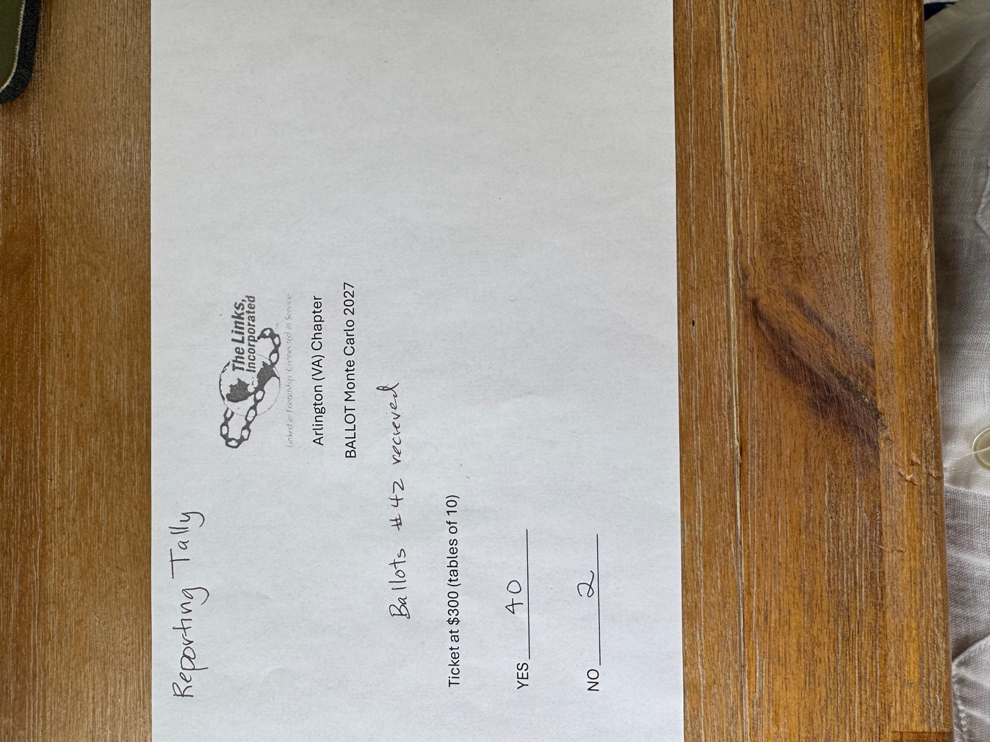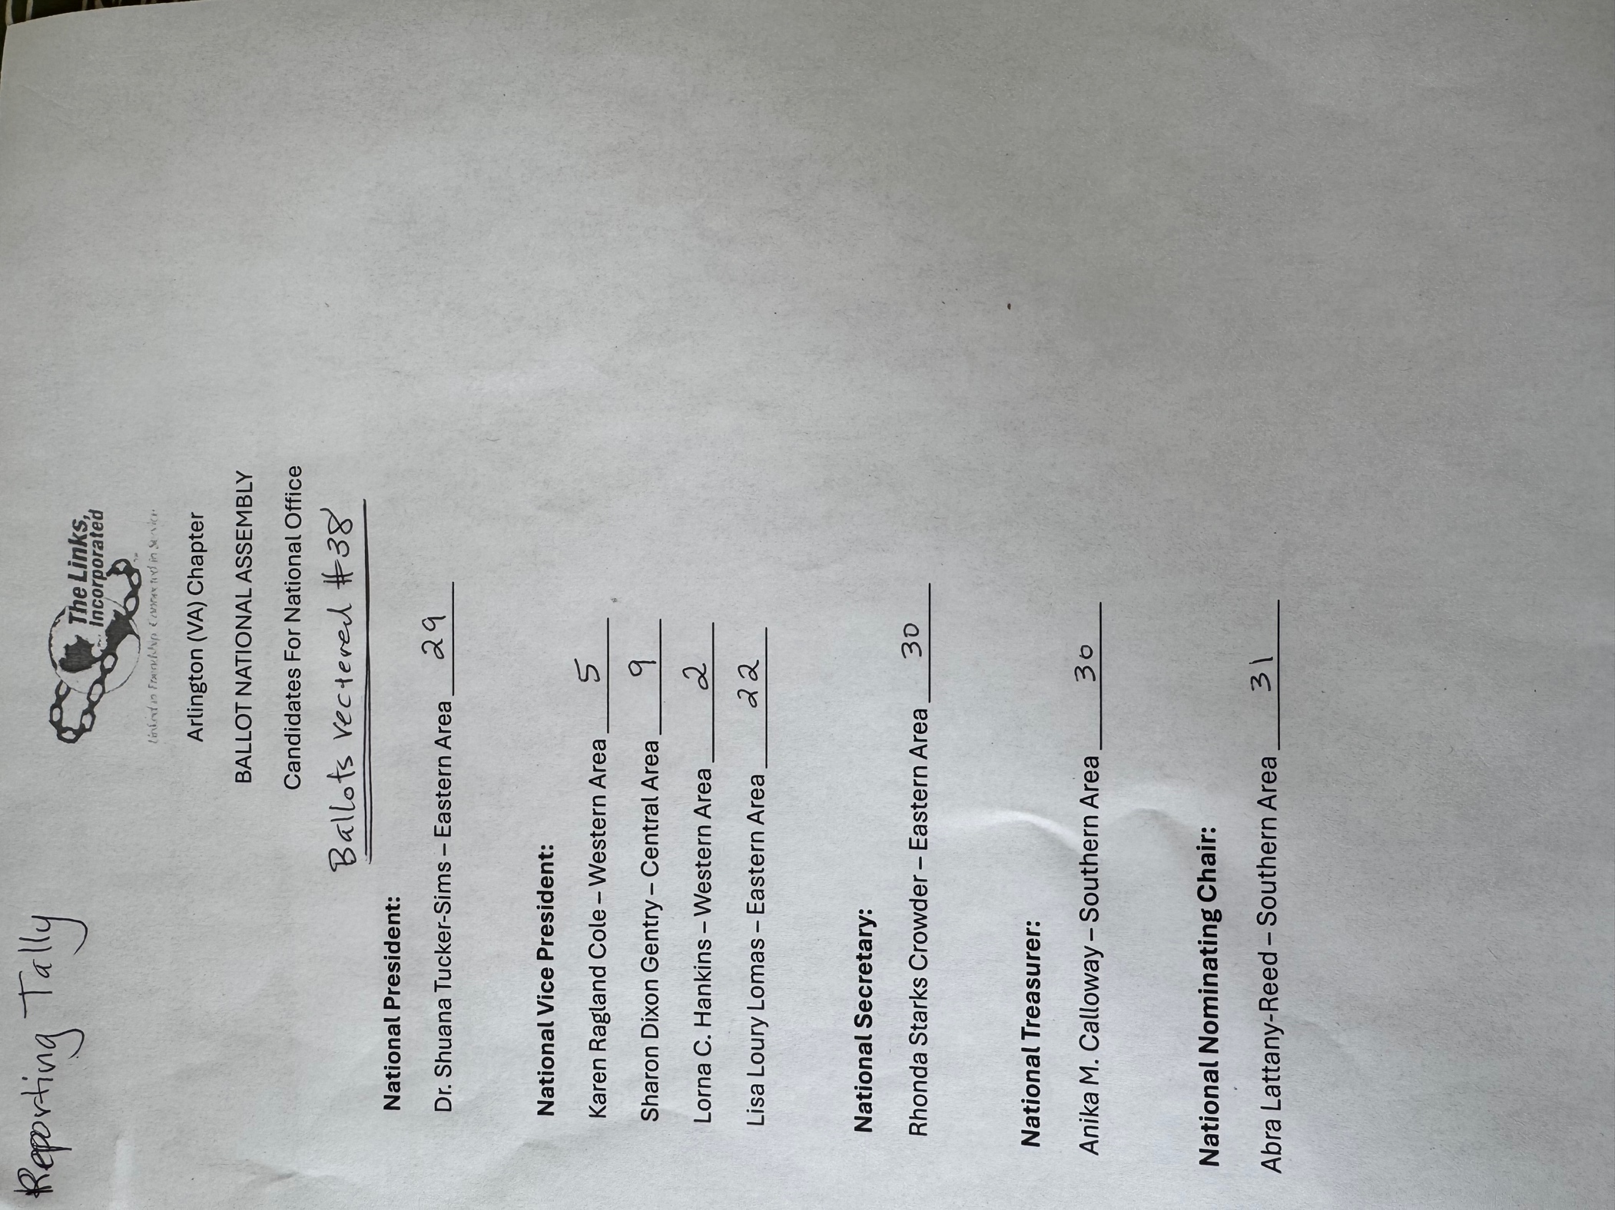
Chapter Attendance, June 13, 2026
First | Last | Status
Aleta | Johnson | 1
Alexia | Hudson-Ward, PhD | 1
Angela | Foster, Esq.
Angell | Jacobs
Anita | Walker
Arkena | Dailey
Ashley | Flakes
Avril Ussery | Sisk | 1
Belinda W. | LaValle
Brenda | Martin, PhD | 1
Bridget Bailey | Lipscomb, Esq. | 1
Candice | Tobin
Caroline | Lang, PhD*
Cheran Cordell | Ivery
Cheryl Coleman | Hall | 1
Chevette | Mooney | 1
Dawn | Johnson
Denise E. | Bruner, MD
DeVera Y. | Redmond
Diane | Butts | Present
Diane M. | Harley | 1
Elizabeth Jackson | Hodges
Emily | Bryant | 1
Evelyn "Evie" | Brown | 1
Evelyn E. | Gee | 1
F. Denise Gibson | Bailey | 1
Faith | Blackburne-Proctor | 1
Felecia Y. | Phillips-Welch | 1
Francine | Lane* | 1
Heather | Hill
Hope | Goins | 1
Isabelle F. | Fant+
Janice | Welburn
Julia A. | Pollard | 1
Karen | Johnson, Esq. | 1
Karen Jordan | Wright | 1
Karen Peters | Hughes | 1
Karyn | Temple
Kedren | Dillard | 1
Keisha Boggan | Campbell
Kelly | Bolden, MD | 1
Kim Campbell | Young | 1
Kimberly Jeffries | Leonard, PhD
Kimberly N. Parker | Pinder
Krysta | Jones | 1
LaJuanna | Russell | 1
Lavern J. | Chatman | 1
Lillie Easley | Parker
Lisa | Gregory, Esq. | 1
Lisa | Lee-Packer | 1
Lori | Stith
Luciana | Gray
Maia | McCuiston, MD
Marietta S. | Palmer, EdD | 1
Martine | Wilson | 1
Melandee | Jones
Michelle M. | Bailey* | 1
Michelle Marie | Jones | 1
Michelle | Mason | 1
Natasha | Rountree | 1
Nicholette M. | Martin, MD
P. Michele | Ellison
Rachel | English | 1
Rose Williams | Boyd* | 1
Sandra Jenkins | Clark | 1
Sudonna | Moss Stevens, Ed.D. | 1
Suzanne | Walker | 1
Tamara | Nall
Tameka | Tunsil* | 1
Tammie | Smiley
Telesa | Via | 1
Tiffany | Johnson Lewis
Theresa | Peterson* | 1
Tycely | Williams
Wendy | Bostic
Yvette | Darnaby* | 1
 | TOTAL | 43

